DNA Replication and Protein Synthesis
An embryonic cell divides again and again. Where there was one cell there are two, then four, then eight, and so on. Each holds all the genetic information needed to create a new human being. Your fingernails grow nonstop, day in and day out. The cells of your fingernails somehow generate the proteins that makes up your nails. How is this protein created? How, exactly, do these cells make copies of themselves? The answers to these questions are DNA replication and protein synthesis. When organisms reproduce, traits are passed from parent to offspring. These traits are carried in DNA, the genetic material found in a cell's nucleus. DNA acts like a blueprint for the cells of an organism, instructing the cells how to put together materials to produce certain traits. DNA stands for deoxyribonucleic acid (pronounced de-ox-ee-ribe-o-new-clee-ick as-id). It's made of just a few kinds of atoms: carbon, hydrogen, oxygen, nitrogen, and phosphorus.
You have probably heard of the DNA molecule referred to as a double-helix. The steps of the ladder are made up of molecules called bases. These nucleotide bases are adenine, thymine, guanine, and cytosine. The bases always pair up so that adenine is joined with thymine (A-T) and cytosine is joined with guanine (C-G). Each rung of the ladder is made of two bases - one for each side of the ladder. The nucleotides join by weak hydrogen bonds. Because they bond at an angle between the two base pairs, the whole structure twists into a helix. These base pairs carry the code for the cell. The sides of the ladder are made up of phosphate and sugar molecules. They do not carry any information. They hold the bases in their proper order.
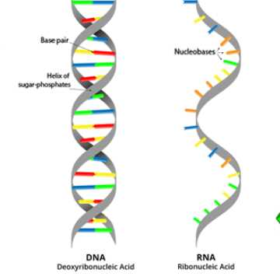
Cells live for only a short time, and so they must replace themselves. As a child grows, his body adds new cells. They do this by a process called cell division and mitosis. Before a cell divides, it copies its own DNA. The two strands of DNA separate. The hydrogen bonds break between the nucleotides, and the strands come apart like the two halves of a zipper. Each strand's complement is recreated. An enzyme makes the complementary strand by adding the correct base to the new DNA strand. Then the cell divides, and each new cell receives one copy of the DNA. The process of copying DNA is called DNA replication. The two resulting double strands are generally almost perfectly identical, but sometimes errors in replication or exposure to chemicals or radiation can result in a less than perfect copy. This is called mutation.
Proteins are required by the body to create new cells, hormones and enzymes. How does a cell use the genetic code to make proteins? Proteins are made with the help of ribonucleic acid (RNA) – a type of nucleic acid that carries the code for making proteins from the nucleus into the ribosomes where protein synthesis occurs. RNA, like DNA is made of smaller subunits called nucleotides however, there are key differences between RNA and DNA. RNA is a single stranded helix. It’s smaller size allows it to fit outside of the nucleus to carry. RNA has the base Uracil instead of Thymine. It is also made of a different type of sugar molecule.
Copy and answer the questions below on loose-leaf paper.
- Describe why DNA is called a “blueprint”.
- List the atoms that DNA is made of.
- Based on your answer to question 2, is DNA an organic compound?
- List the rules for base pairing in a DNA molecule.
- Describe what causes the DNA molecule to twist into a double helix.
- What part of the DNA molecule holds the genetic code?
- Use the base pairing rules to create the complementary DNA strand for the DNA listed below.
DNA Strand = AGTCTTGGCCAATGCCATT
Complementary Strand =

- Describe the function of the phosphate and the sugar molecule in a DNA nucleotide.
- Describe what occurs during DNA replication.
- Why are proteins required by the body? Give 2 specific examples.
- Describe the 3 differences between DNA and RNA
- What organelle does protein synthesis occur in?
- Describe the role of RNA in protein synthesis.
- Explain why being single stranded helps the RNA function.

