Name: ____________________________ Date Completed:___________________

Class: ____________ Lab Minutes: _______________ Teacher: ___________________

Lab #2: Tools for Measurement

Introduction
During laboratory investigations, you are often required to make measurements of length, mass, and volume. You need to know the proper pieces of equipment to select and the appropriate procedures and units to use.

Length Measurement
Typically a metric ruler is used to determine the length of an object. To measure length, use either centimeter (cm) or millimeters (mm). You should know how to convert millimeters to centimeters and vice versa.
The metric ruler we are working with is calibrated – or scaled – in centimeters. The lines indicated by numbers 1, 2, 3 and so on each represent a distance of 1 centimeter. The smaller divisions each equal 1 millimeter (10 mm = 1 cm).

Volume Measurement
A graduated cylinder is often used to measure a liquid’s volume, or the space it occupies. Liters and milliliters are typically used to indicate volume in the metric system. Graduated cylinders are calibrated in milliliters (mL).
Water and many other fluids form a meniscus (curving surface) when placed in the narrow tube of a graduated cylinder. To correctly read the volume of the liquid, place the cylinder on a flat surface. Then read from the bottom of the curved meniscus at eye level.
Read the measurements in the cylinders pictured below and fill in the answers in correct units.

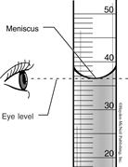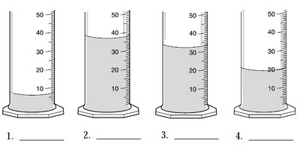

Mass Measurement
In the laboratory, mass– the quantity of matter in something – is often measured with a balance, which is a tool that works by comparing an object of unknown mass with an object of known mass. A triple-beam balance is used to measure mass. It has a single pan and three bars (beams) that are calibrated in grams. One beam, the 500-gram beam, is divided into five 100-gram units. Another beam is divided into 10 units of 10-gram totaling 100 grams.
The front beam is divided into 10 major units of 1 gram each. Each of these units is further divided into 0.1-gram units.
Before using a balance, make sure that the pan is empty and that the pointer and all of the
riders (devices that are moved along the beams) are on zero. To determine the mass of an
object, it is first placed on the pan. Then, starting with the 500-gram beam, the masses on the beams are adjusted until the pointer is again pointing to zero. The mass of the object is the sum of the readings on the three beams.

Using the Triple Beam Balance: Look at the picture below. What is the mass of the rock being measured? ________________g

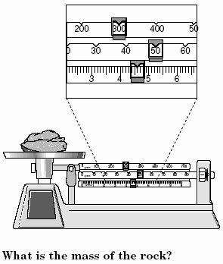

Activity Directions: Measure the following items and convert the values to the measurements given.

Distance:
1. Measure the length of the index card and record the measurement. _______cm
2. Change this measurement to ______________mm.
3. Measure the width of the card and record the measurement. ________cm
4. Change this measurement to ___________mm.
5. Measure the width of the loose leaf paper in cm. _________ cm. Change this to meters _________m Change this to mm. ____________mm.
6. Measure the length of the room in cm. ________ cm Change this to meters _________ m Change this to mm. ____________mm.

Volume: Fill a Dixie cup with water and determine its volume by pouring the water into a graduated cylinder. Record its volume in milliliters and liters in the space below.
Dixie Cup: ___________mL ___________L

Mass: Weigh the following materials to the nearest .1 gram.
1. Notebook ________g. __________Kg.
2. Set of keys ________g. _________Kg.
3. One shoe (use paper on the scale- weigh it first, subtract this weight from the total
weight) ________Kg. _________g.

Conclusion: Answer the following questions:
1. What is the metric value for mass? _____________________________
2. What is the metric value for length or distance? ________________
3. What is the metric value for volume? _____________________
4. What is one cubic cm (cm3) equal to? _________________
5. What is the prefix value for 1000X? _____________
6. What is the prefix value for 1/100? _____________
7. What is the prefix value for 1/1000? ______________
8. If we are moving from a large value to a small value, we move the decimal point to the
______________.
9. If we are moving the decimal point to the right we are moving from a ___________ value to a ____________ value.

