Topic One: Chemistry of Living Things
- All living things must maintain homeostasis in order to stay alive.
  - Homeostasis: _______________________________________________________________
  - Failure to maintain homeostasis results in ______________ or ____________________
  - Homeostasis is often maintained using ______________________ mechanisms.
    - Feedback mechanisms are cycles in which the product of one reaction causes another to start or stop.
  - While organisms are balanced, they are not unchanging. The term used to describe the balanced state is dynamic equilibrium.
    - Dynamic Equilibrium: A balanced state created by many small, opposing changes.

- Life Processes: All living things carry out the same basic chemical processes. Taken together, these process make up an organism’s __________________________.
  - Metabolism: _______________________________________________________________
    - ____________________: Using nutrients for growth, synthesis, repair and energy.
    - ____________________: Converts energy in food into a usable form (ATP).
    - ____________________: Making complex chemicals from simple substances.
    - ____________________: Absorbing and distributing materials throughout the body.
    - ____________________: The control and coordination of life processes.
    - ____________________: Removing of wastes produced by metabolic activities.
    - ____________________: Passes on genes to offspring.

- Inorganic Chemicals: Simple compounds
  - Water ( _____) : Most common substance in all living things (about 60% of body mass)
      - Needed for chemical reactions (won’t happen in “dry” conditions)
      - Dissolves other molecules into solution, allowing them to be transported through the body.

  - Oxygen (______): Needed by most (not all) organisms for cellular respiration.
      - Released by plants and algae as a waste product of _________________________.
      - Aerobic respiration: Process that uses oxygen to extract energy from glucose (sugar). Used by most organisms.
      - Anaerobic respiration: Process that extracts energy from glucose without using oxygen. Gives less energy, so only used by some simple organisms (some bacteria, yeast). These organisms do not need to breathe in oxygen.

  - Carbon Dioxide (______): With water, used by plants to make glucose (photosynthesis).
      - Waste product of aerobic respiration.

  - Nitrogen (_____): Most common gas in air (70%)
      - Needed to make protein.
      - Converted into ______________ by soil bacteria. Nitrates are absorbed by plants and then eaten by animals.
      - Excreted as waste in _________________ or __________________.

  - Acids and Bases: Used for different functions in body (such as digestion).
      - Measured by the pH scale
      - Very high and very low pHs are usually lethal.
      - pH can affect rates of chemical reactions; for example, digestive enzymes work fastest in acidic environments, which is why we make stomach acid (hydrochloric acid, or HCl).

- Organic Compounds: Larger, more complex chemicals. Always contain the elements carbon (C)and hydrogen (H). Synthesized from simpler substances (building blocks).
  - Carbohydrates: ___________________________________
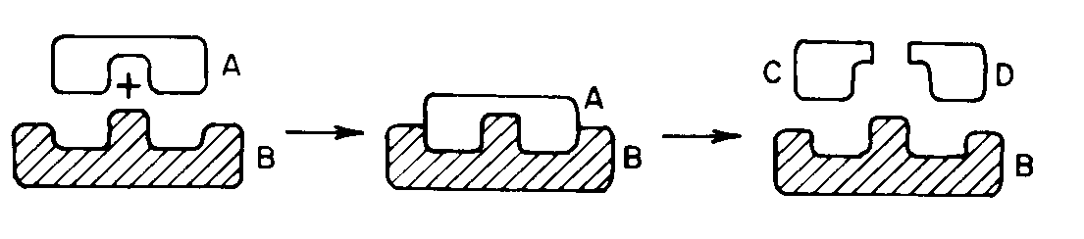
    - Building blocks: _____________________
    - Functions:
      - _________________
      - _________________ (starch)
A starch (A) is broken down by an enzyme (B) into two simple sugars (C, D). This is also a good example of the lock and key model.

  - Lipids: _________________________________________
    - Functions:
      - _________________
      - _________________
      - _________________
      - _________________

  - Proteins: Complex compounds that carry out all the body’s activities.
    - Building blocks: _________________
    - After water, proteins are the most plentiful substances in the body.
    - Have many different functions as determined by their ___________.
    - Lock and Key Model: Proteins must have the right shape to “fit” with other molecules.
      - Changing the shape of a protein will change what it can interact with its function.
    - Important types of proteins:
      - Hormones and neurotransmitters – carry messages through the body.
      - Cell receptors – in cell membrane; receive hormones and neurotransmitters.
      - Antibodies – attack foreign pathogens
      - Enzymes- act as catalysts, controlling all chemical reactions in the body.
        - High temperatures will cause enzymes to denature (lose their shape) and stop functioning. This is why high fevers are dangerous.

  - Nucleic Acids (DNA and RNA): Make up genes and chromosomes.
    - Building blocks: Nucleotides; molecular bases (ATCGU)

Topic Two: The Cell
- Definition: __________________________________________

- Cell Theory has three parts:
    - _______________________________________________________________________
Unicellular – single celled organisms (amoeba, paramecium)
Multicellular – have more than 1 cell; may be only a few (vorticella), or many trillions of cells (humans). Almost all structures in multicelled organisms are made of or by cells.

    - _______________________________________________________________________
Everything you do is the result of the work of your cells – walking, talking, even thinking and feeling. When you get sick, it is because your cells are not working correctly.

    - _______________________________________________________________________
This seems obvious now, but at one time people believed in spontaneous generation, the idea that living things regularly emerged from nonliving things.

  - Exceptions to the Cell Theory
    - ________________ are not made of cells. However, they also do not carry out all life processes, so many biologists do not consider them true living things.
    - ____________________ obviously could not come from another cell.

- Organization

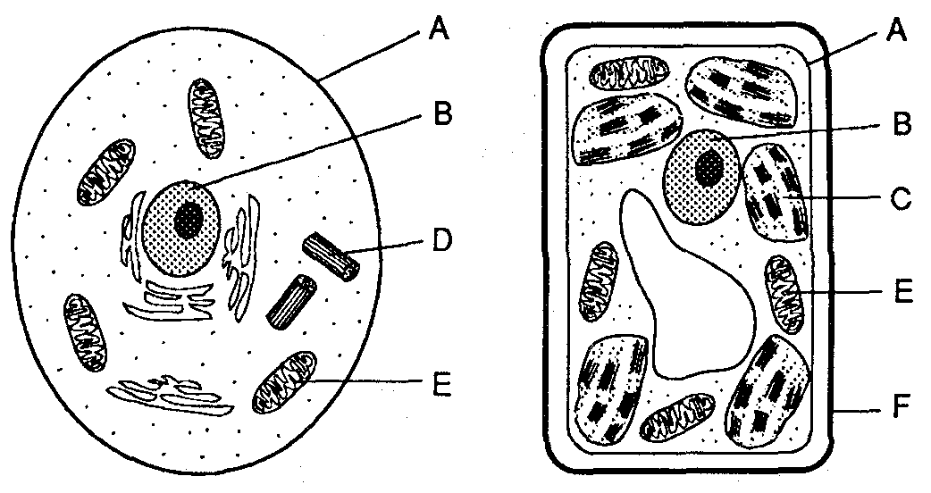
- Cell Organelles: These are the tiny cell parts that make up a cell.
    - ___________________
      - Controls the cell
      - Contains hereditary material (chromosomes, genes, DNA)
    - ______________________
      - Fluid/liquid in the cell – mostly water
      - Helps transport material
    - _______________________
      - Carries out cellular respiration.
      - Gives cell energy (Powerhouse of the cell).
    - _______________________
      - Makes proteins from amino acids.
    - ________________________
      - Stores food, water and waste
      - Food vacuoles may digest large molecules.
      - Waste vacuoles may excrete waste out the cell membrane
    - _______________________
      - Carries out photosynthesis
      - Plant and algae cells only
    - _______________________
      - Gives shape, structure and protection.
      - NEVER found in animal cells.
    - ________________________
      - Separates cell interior from environment
      - Controls what enters and leaves the cell using _______________ ________________.
      - Has ___________________ ____________________ that pick up signals from other cells.
      - Has ________________________ which are proteins that identify the cell; prevent the cell from being attacked by the immune system.

Topic Three: Nutrition, Photosynthesis and Respiration
Reminder: All life processes are chemical activities which make up your metabolism.
- Nutrition: Taking in nutrients (food) for various activities including:
    - _______________________
    - _______________________
    - _______________________
    - _______________________
  - Ingestion: ______________________________________________________
  - Digestion: ______________________________________________________
    - Nutrients must be broken down into smaller parts so that they can be ________________ into the blood and cells of organisms.
      - Starches are digested into __________________.
      - Proteins are digested into ___________________.

  - Autotrophic Nutrition: Organisms take ______________________ materials (______, ______) and convert them into organic nutrients (__________________).
    - Auto = _________ ; troph = ____________ so Autotroph = _______________________
    - ______________________ is most common form of autotrophic nutrition
    - Ex: _____________________________________

  - Heterotrophic Nutrition: Organisms must __________________ nutrients made by other organisms.
    - Hetero = ___________, so Heterotroph = ___________________________.
    - All _____________________ and _______________ are heterotrophs.
    - Includes:
      - Carnivores: _____________________________________
      - Herbivores:_____________________________________
      - Ominivores:_____________________________________
      - Decomposers:___________________________________
- Photosynthesis: Process in which sun’s energy is trapped in the chemical ________ of sugar.
  - Requires _________________, ________________ and __________________.
  - Makes ___________________ (_________________) as food.
  - ____________________ and ________________ are waste products.
  - Benefits:
    - Provides food for all plants, animals and other organisms.
    - Provides _____________ to breathe.
    - Removes _______ from atmosphere.
  - Plant adaptations:
    - Chloroplast: Cell organelle that does photosynthesis
    - Gas exchange:
      - Stomates : __________ under a leaf; let gases in and out
      - Guard cells: open and close stomates to prevent _________________________
    - Transport:
      - Xylem and Phloem: “tubes” transport food and water throughout the plant.

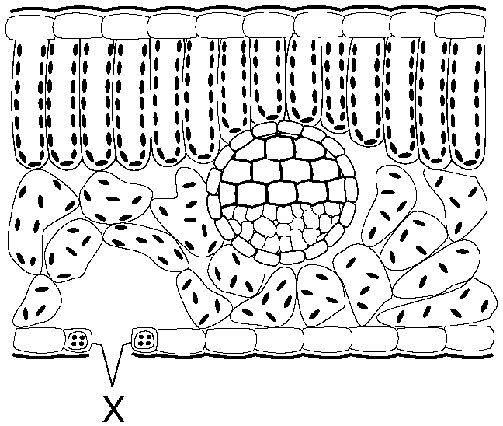
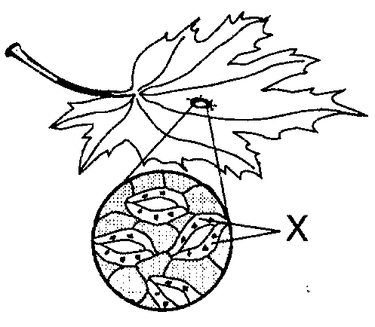

Two different views of the stomates and their guard cells (X).

- Cellular Respiration: Process that takes energy from sugar molecules and places it in molecules of _________.
  - ______ is the molecule all life uses for energy.
      - No organism can get energy from sunlight or sugar without first putting the energy into ATP.
  - Requires _________________, ________________ and __________________.
  - ____________________ and ________________ are waste products.

  - Most organisms carry out aerobic respiration (uses oxygen) in their mitochondria.
  - Anerobic respiration does not require oxygen, but gives less ATP (energy) for each molecule of sugar.
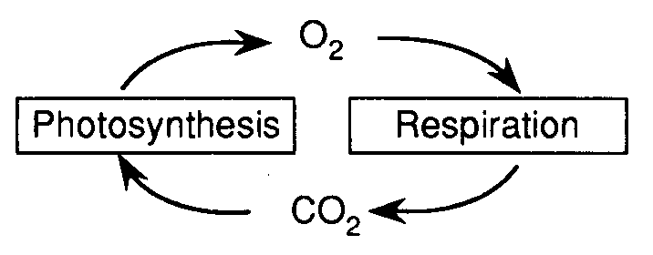
      - When exercise causes human muscles to run out of oxygen, their cells will do anaerobic respiration. The waste product, lactic acid, causes muscles to “ burn” so that you will stop.

  - Photosynthesis and Cellular Respiration are opposite reactions! They are also important in cycling oxygen, carbon, hydrogen and water through the environment

  - Common mistakes:
      - “Plants use photosynthesis, animals use respiration.”
All organisms, including plants, use respiration to get their energy.

      - “Respiration is breathing.”
Breathing is not respiration. Breathing exchanges the gases needed for respiration. Inhaling and exhaling does not give you ATP.

      - “Oxygen is used to breathe.”
This is backwards. Breathing is used to get oxygen which is used for respiration. Without oxygen, you have no respiration, no ATP, and no energy.
      - “All living things need oxygen/need to breathe.”
Anaerobic organisms do not need oxygen, and do not have to breathe.
Topic Four: The Human Body
- Organization: The human body is made up of ___________.
  - All humans (and most other organisms) begin life as a ______________ cell.
    - This single cell is called a ___________________.
    - The nucleus of this cell has _________ the genes needed to become a complete organism.
  - Humans grow as a result of ______________(cell division).
    - This quickly increases the number of cells in the body until there many trillions of cells.
    - Since all new cells come from the same single cell, they all share the same __________.
  - As cells divide, they begin to develop into specialized tissues.
    - Specialization or Differentiation: Process in which a cell changes to have a special shape and function.
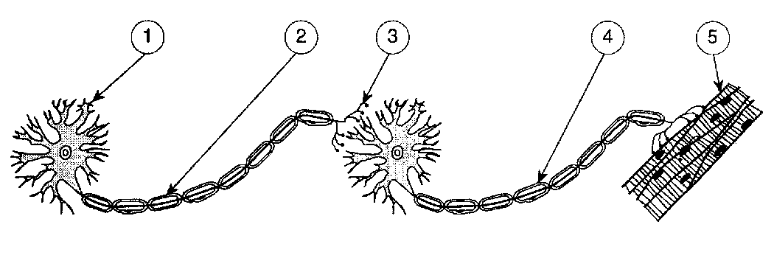
    - Cells specialize by turning specific genes on or off.
      - Ex: A white blood cell has turned off all genes needed to make skin, bone, or nerves. It still has those genes, but only the genes needed to be a white blood cell remain turned on.
  - As the body continues to develop, tissues will work together to form ____________ .
  - Organs will work together to form ______________ ____________________ .
Two neurons carry an impulse to a muscle cell. (3) shows where a neurotransmitter would carry the signal from one cell to the next.

  - Org an systems will work together to help a person maintain homeostasis.

- Nervous System
  - The nervous system __________________ your body with electrochemical ______________.
    - The chemical portion of a nerve impules is called a ____________________________
    - Neurotransmitters released by 1 nerve cell are received by _______________________ _______________________ in the cell membrane of the next nerve cell.
    - The shape of the receptor molecule determines which neurotransmitter it can receive.
  - A nerve cell is also called a ___________________.
  - The main organs of the nervous system are the ___________ and ___________________
  - The spinal cord controls reflexes and relays impulses between the brain and body.

- Endocrine System
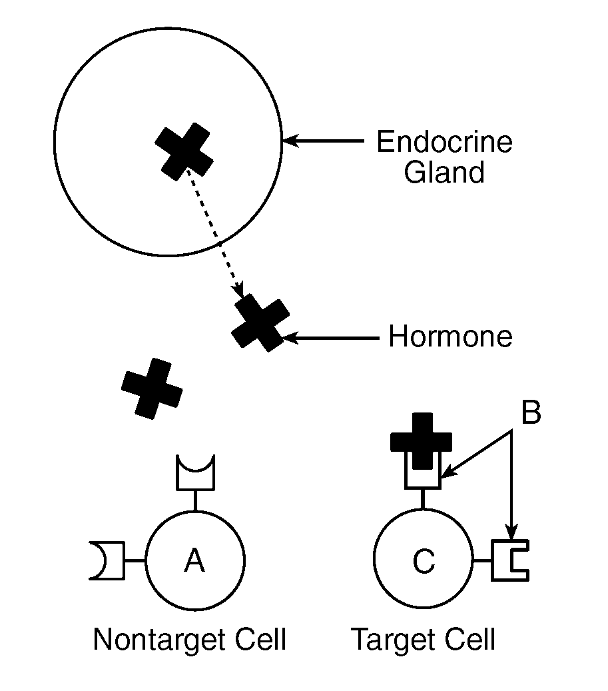
  - Uses _________________ to regulate the body.
    - A hormone is a chemical ___________________ secreted by endocrine glands.
    - Hormones are slower than nerve impulses, but with longer lasting effects.
    - Hormone levels are controlled by feedback mechanisms.
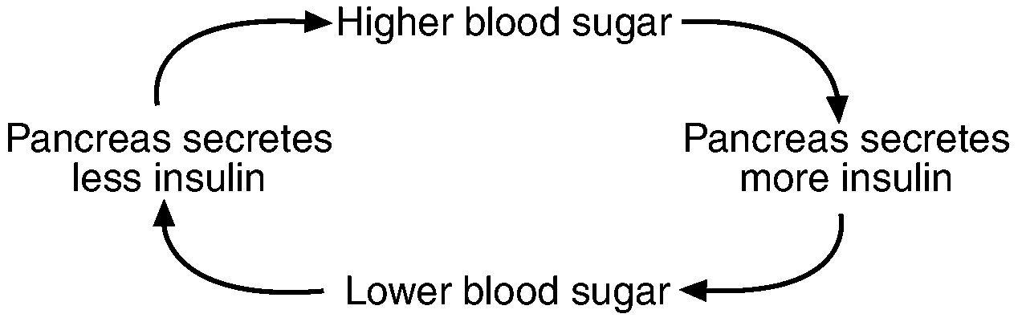

A feedback mechanism

    - Receptor molecules on the surface of the cell membrane receive hormones. As with all proteins, it is the shape of the receptor molecule that determines which hormone it can receive.
Receptor Molecules in the cell membrane can only accept molecules of the correct shape. This is a good example of the Lock and Key Model.
  - The _________________ makes ______________ and glucagon which control blood sugar.
      - Common mistake: “Insulin lowers blood pressure.”
Insulin (and glucagon) directly control blood sugar (or glucose) levels, not blood pressure.
  - Adrenal glands make adrenaline when the body is under stress.
  - Testosterone (male), estrogen and progesterone (female) are the sex hormones. These are made in the gonads (testes for males, ovaries for females).
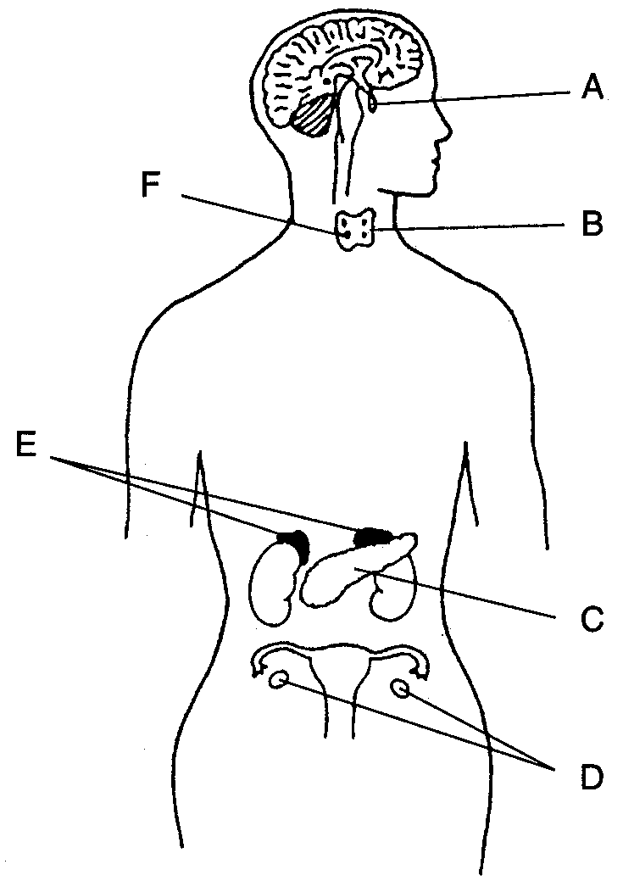
The brain (nervous system) and some endocrine glands.

Circulatory System

Moves material through the body to the organs and cells that need them.
  - Transported material includes:
    - _________________ and ________________from intestines to all cells of body.
    - _________________ from lungs to all cells of the body.
    - _________________ from glands to target cells
    - _________________ from all cells to the excretory organs.
  - Materials usually enter and leave the blood through diffusion.
    - Diffusion: Process in which material moves from a high concentration to a low concentration.
      - Ex: There is a high concentration of oxygen in the lungs, so oxygen will diffuse from the lungs into the blood, which has less oxygen.
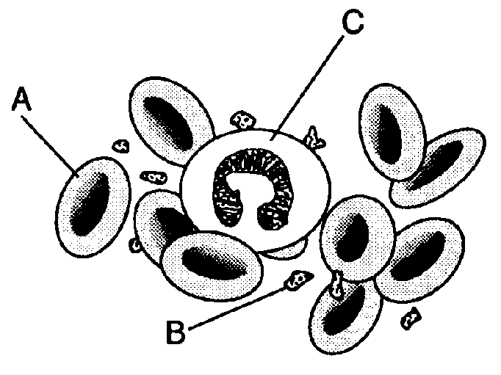
    - __________________________: Microscopic blood vessels where diffusion occurs.

The______________ is the pump that drives the circulatory system.

___________________ carry oxygen and carbon dioxide
    - Hemoglobin: Protein in red blood cells that carries oxygen.______________ is the fluid of the blood. It transports everything except oxygen.
  - Platelets clot the blood.

Common mistakes:

“The heart pumps oxygen to the brain.”

Technically true, but the heart pumps blood (which carries the oxygen) everywhere in your body.
Red blood cells (A), platelets (B) and white blood cells (C)
.

“Oxygen diffuses into and out of the heart.”

No materials diffuse in or out of the blood when it is in the heart. This only occurs in capillaries.

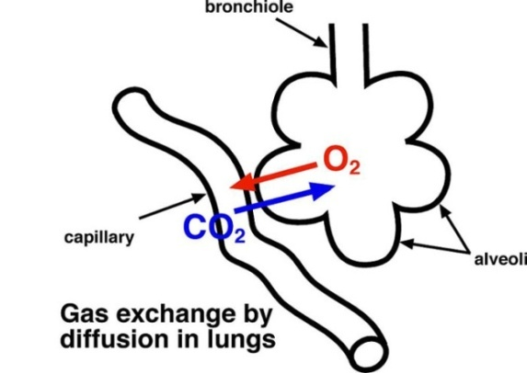
Respiratory System:

Breathing provides _______________ needed for cellular respiration (which uses energy from sugar to make __________).

Excretes the waste _________ which is produced from cellular respiration.

The diaphragm is the muscle that allows breathing to occur.

You breathe faster when CO₂ builds up in the blood (not when you need oxygen).

The alveoli are microscopic sacs where oxygen enters the blood and CO₂ leaves the blood.

The alveoli are surrounded by capillaries which pick up oxygen and drop off CO₂.

- Digestive System:
  - Food is broken down so that it is small enough to enter the body tissues/cells.
    - Food is broken down mechanically and chemically.
    - Nutrients and water are absorbed into the body in the small and large intestines.
  - The digestive system is a one way passage through the body that includes the mouth, stomach and intestines.
  - Food is moved through the digestive system by muscular contractions (peristalsis).
  - Undigested food is eliminated as solid waste (feces).
  - Common mistakes:
    - “The digestive system excretes waste.”
The digestive system does not excrete waster (see excretory system).
    - “The digestive system gives you energy.”
The digestive system gives nutrients. Energy is gained by cellular respiration.
Kidneys and Urinary Tract - part of the human excretory system.
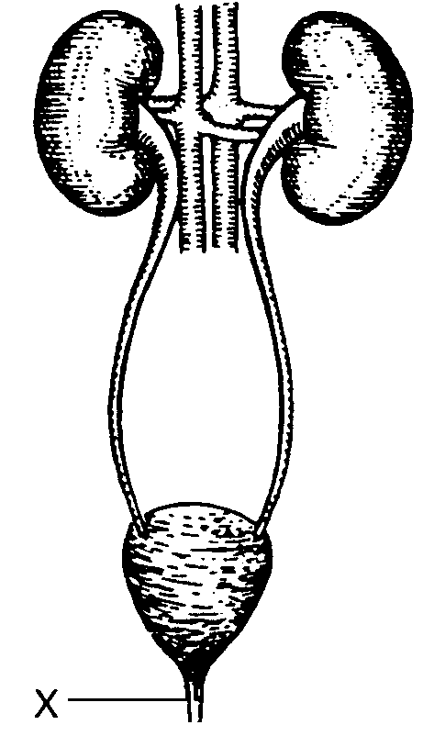

Excretory System:

Removes waste produced by the cells of your body.

These wastes include _________, ___________, _____________ and __________.

Lungs excrete ________ and ___________.

The skin excretes _________ and _________ as sweat.

The kidneys excrete ___________ and ______________ and other substances as urine.

Kidneys also control the amount of ____________ in your body.

The liver filters toxins and dead red blood cells from the blood.

Common mistake:

“The body excretes feces.”

Feces never enters cells of the body, so technically it is not excreted. The correct term is “eliminated” or “egested.”

- Immune System
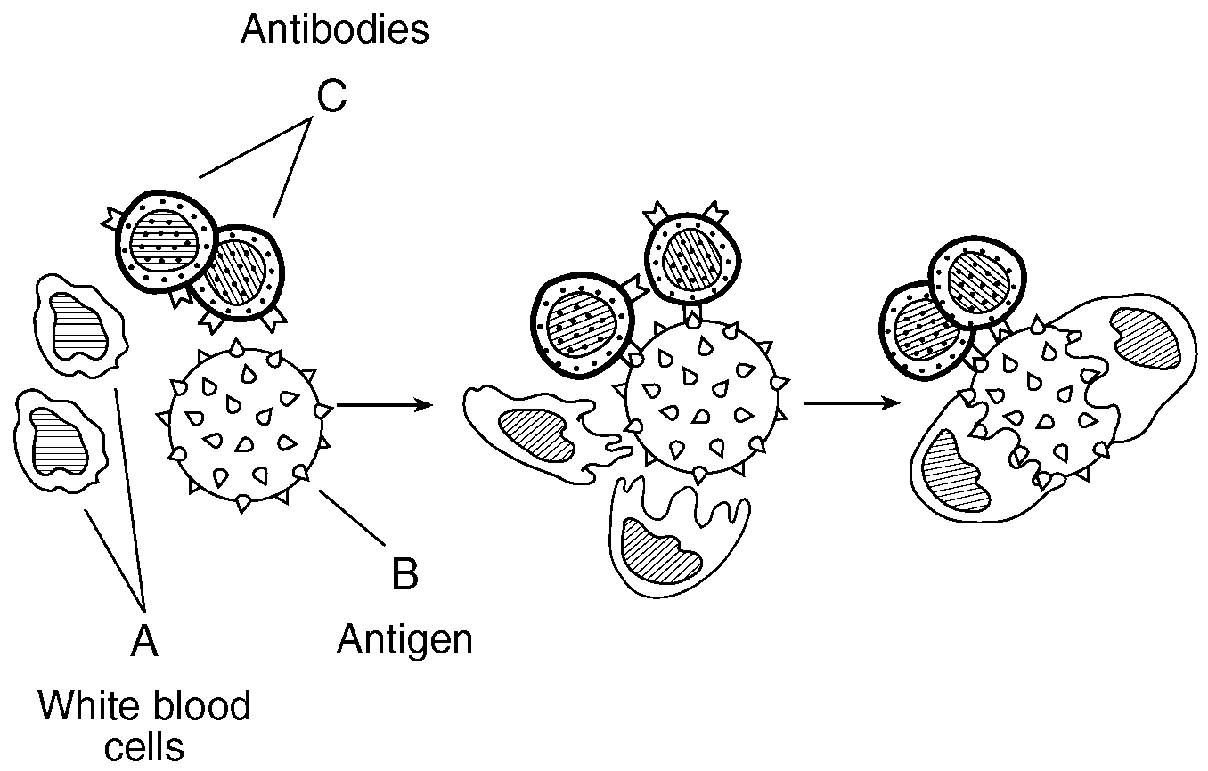
  - The job of the immune system is to protect the body against ___________________.
  - Pathogen: ____________________________________________________________.
    - Types of pathogens include viruses, bacteria, and parasites.
  - White Blood Cells are the main components of the immune system.
    - Different w.b.c’s have different roles, including:
      - Identify pathogens
      - “Tag” pathogens for destruction by other wbc’s.
      - Destroy pathogen by eating it.
      - Destroy pathogen using chemicals
      - Make antibodies
  - Antibodies are _______________made by white blood cells to attack pathogens.
    - Every antibody is specific in its action – it can attack one and only one type of pathogen. As with all proteins, this is because the shape of the antibody must fit its target (lock and key model).
  - Antigens are protein “tags” that identify a cell or virus.
An immune response – white blood cells and antibodies attack a virus.
    - Your blood type is determined by your antigens (you can have A or B antigens, both or nether (type O).
    - Any cell of virus with the wrong antigen will be seen as foreign by your immune system, attacked, and destroyed. This is why you must match blood types before receiving blood or an organ transplant.
  - A ___________________ is an injection of a dead or weakened pathogen.
    - Triggers the body to make antibodies against that pathogen.
    - Effective against both viruses and bacteria.
    - Can only prevent disease, not cure it.
  - ____________________ are drugs used to stop infections by bacteria.
    - Antibiotics will not work against viruses.
    - Unlike vaccines, antibiotics can cure diseases.
  - Common mistake:
    - “Antibodies are cells that attack pathogens.” Antibodies are proteins, not cells.

- Interactions between body systems
  - The different systems of the body work together to maintain homeostasis. For example:
    - Nutrients from the _________________ system are transported to cells by the __________________ system.
    - Wastes from the _________________ system are removed by the _______________ system.
    - The ___________________ and __________________ systems work together to control the body.
    - The ___________________ system protects the ________________ system from disease.

- Diseases and Disorders
  - Typically the exam asks you to name a disease, what causes it, its effect on the body, and how to prevent/treat/cure it. The most important diseases and disorders for you to know are:
    - AIDS
      - Caused by HIV virus (a pathogen)
      - Weakens human immune system, leaving body vulnerable to other diseases.
      - Spread through bodily fluids, usually sexual contact, intravenous (IV) drug use (sharing needles), or blood transfusions.
      - Can’t be cured, but spread may be prevented by sexual abstinence, “safe” sex (using condoms), not sharing needles, or testing blood before using it for a transfusion.
    - Cancer
      - Caused when a cell reproduces (divides) at an uncontrolled rate, forming a tumor.
      - Cancer cells do not specialize and take resources from healthy tissue.
      - May be caused by radiation, chemicals (such as asbestos or cigarette smoke), and viruses.
      - Treatments include surgery, radiation therapy, and chemotherapy.
    - Diabetes
      - Affects body’s ability to control blood sugar.
      - Some diabetics may be treated using injections of insulin made by genetically engineered bacteria.
    - Allergies
      - Occur when immune system reacts to a harmless substance (such as pollen)
      - Asthma is a form of allergy caused by a reaction to dust particles in the air.
Topic Five: Reproduction
Mitosis vs Meiosis.Notice the number of chromosomes stays the same in mitosis, and is halved in meiosis.

- Asexual reproduction:
  - Advantages: _______________________________
  - Disadvantage: _______________________________

- Sexual reproduction:
  - Advantage: _______________________________________
  - Disadvantage: _____________________________________

- Mitosis
  - Used in all forms of asexual reproduction.
  - The number and types of chromosomes in the daughter cells are ______________ as in the parent cell.
  - Large organisms use mitosis for ___________and _____________. Simple organisms use it to reproduce.
  - One division of a cell two identical, diploid (2n) cells.
    - Diploid: Cell with a ________ sets of chromosomes.

- Meiosis
  - Makes ______________ used in sexual reproduction.
    - Gamete: Sex cells; egg and sperm
  - One cell divides twice four DIFFERENT haploid (1n) cells.
    - Haploid: Cell with __________ set of chromosomes ( ½ normal)
  - Separates pairs of chromosomes so that offspring get ________ chromosome of each pair from that parent.
  - Each daughter cell (gamete) gets only one half of the chromosomes of the “parent” cell.

- Male Reproductive System
  - ______________ produce and store sperm.
    - Sperm are haploid cells made by ______________
    - Sperm are produced in large numbers throughout a males life
    - Sperm are smaller than the egg and mobile
    - Sperm only provide offspring with 23 chromosomes – everything else is in the egg.
  - Testosterone is the male sex hormone, and is made in the testes.
  - Penis transfers sperm into the female reproductive system.
  - Semen is the fluid that carries sperm.
    - Semen contains sugar to give sperm energy.

- Female Reproductive System
  - ________________ produce eggs.
    - Eggs are haploid cells made by _______________.
    - Females are born with all eggs they will ever need.
      - An egg is not fully developed until ovulation
      - Females are born with millions of eggs, enough for several lifetimes.
    - Eggs are largest cells in the body.
    - Eggs do not move on their own.
    - Contain 23 chromosomes and all cell parts (mitochondria, ribosomes,etc) that the offspring will need to grow and develop.
  - The menstrual cycle lasts 28 days (on average)
    - Ovulation – release of an egg (typically 1 per cycle)
    - Menstruation – shedding of the uterine wall if fertilization doesn’t occur
    - If pregnancy occurs, the menstrual cycle will temporarily stop.
  - The _______________________________ carries the egg to the uterus.
  - The ______________ is the womb where the baby will develop.
  - The vagina is the birth canal where the baby will leave the body.
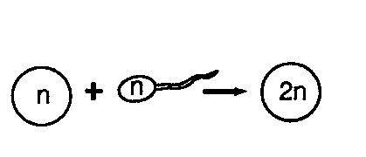
- Development
  - Fertilization occurs in the _____________________________.
    - A fertilized egg is called a ________________.
    - Fertilization restores the complete set of chromosomes, so the zygote is diploid (23 from the egg + 23 from the sperm = 46).
  - A zygote develops in the following order:
Fertilization retores the correct number of chromosomes.

    - Cleavage – A form of _________________; cells divide but do not differentiate
    - Differentiation – Cells begin to form into tissues and organs
    - ______________
    - ______________– most major organs are formed (but not completed)
      - Continues to grow through cell division (mitosis)
  - The__________________ transfers nutrients and oxygen from the mother’s blood into the blood of the fetus through the process of ____________________.
    - The blood of the mother and fetus do not mix.
    - The fetus is attached to the placenta by the ______________________.
    - Waste produced by the fetus is also removed by the placenta.
      - Waste (CO₂, urea, salts) diffuse from placenta into mother’s blood.
      - Since the fetus does not eat solid food, it does not have to eliminate feces.
  - The child is vulnerable to alcohol, drugs, etc because organs and systems are still developing.
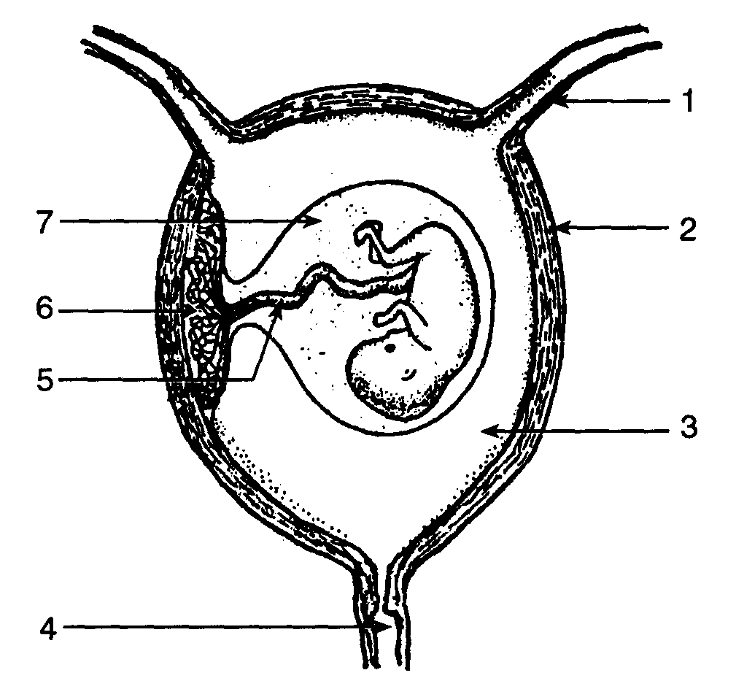
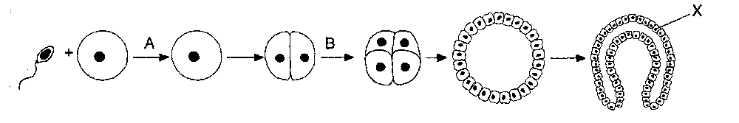
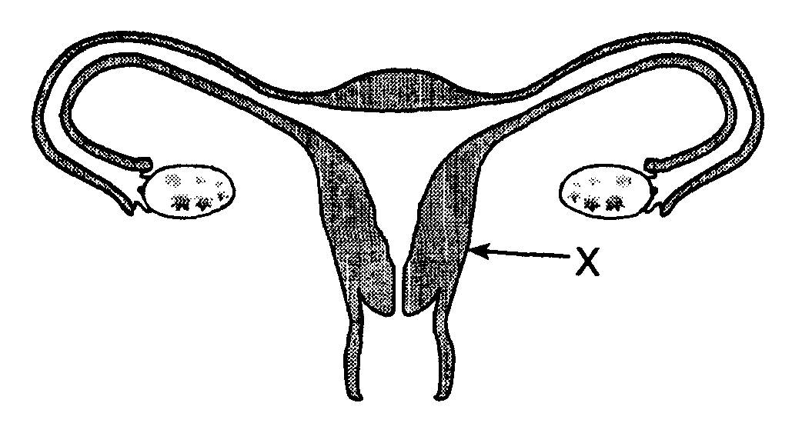
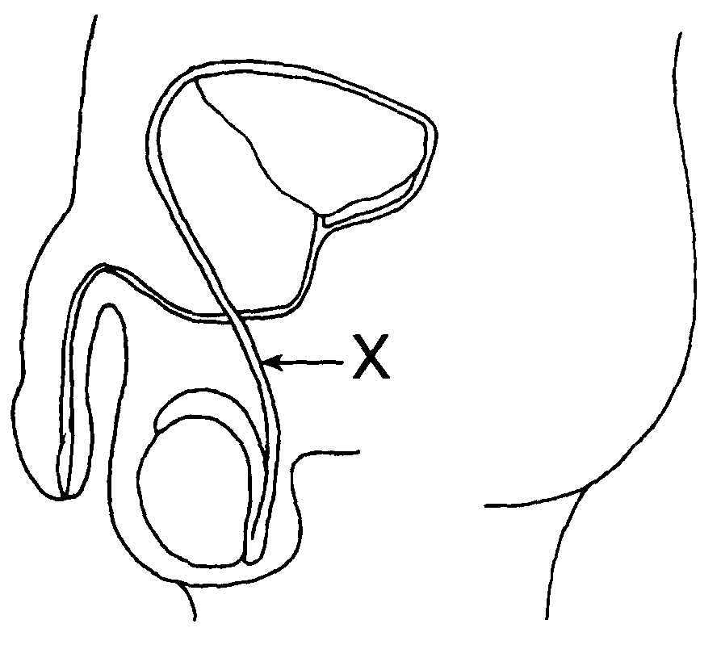
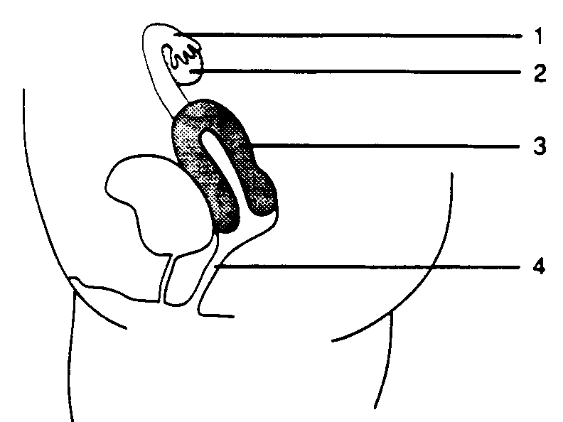
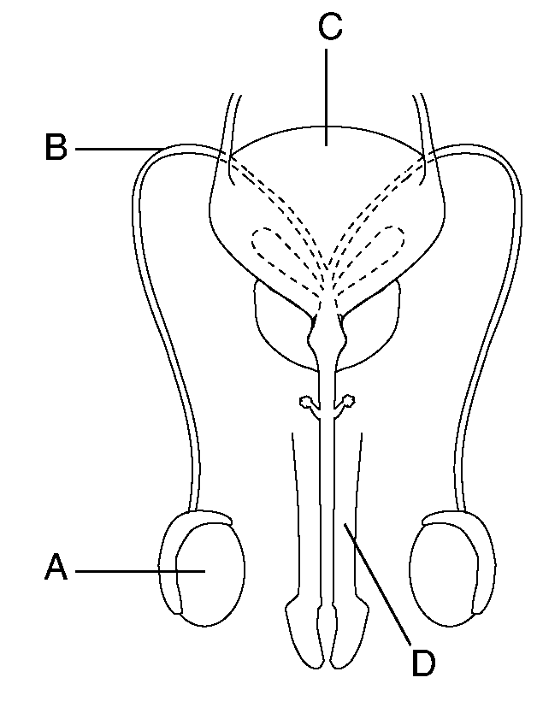
Early development – Fertilization (A) forms a single celled zygote which then begins the process of cleavage (B) which will eventually create a layered ball of cells that will form the embryo.

Late Development – The fetus pictured here is nearly ready to be born. Note the umbilical cord, placenta and amniotic sac.
Front and side views of the male and female reproductive systems
Topic Six: Genetics
- Chromosomes:
  - Humans have ______ chromosomes, or ______ homologous pairs.
    - Homologous: ______________________________________________________
  - Chromosome pairs carry genes for the same traits.
    - Most organisms have two genes for each trait - 1 from each parent, 1 on each member of the homologous pair.
  - Sex chromosomes – In humans, females are ______ and males are ______.
    - The Y chromosome is much _____________ than the X, so it is missing many genes. This means many genes on the X chromosome do not have a “partner” so:
      - If a male has a recessive trait on the X chromosome, the Y chromosome will not be able to “hide” it with a dominant gene, so...
      - This makes males more likely to have some traits (like color blindness). These are called sex linked traits.
  - Common mistake: “Humans have 23 chromosomes (or 46 pairs of chromosomes, or some other incorrect number).”
These numbers are often confused. You must memorize them correctly.

- Chromosomes and Genes
  - Each chromosome has hundreds or thousands of genes.
  - Each gene codes for a particular protein.
    - Common mistake: “Genes/DNA are made from protein.”
Genes carry the instructions to make protein. The genes themselves are made from nucleic acids.
    - While genes determine our traits, the environment can affect expression of genes.

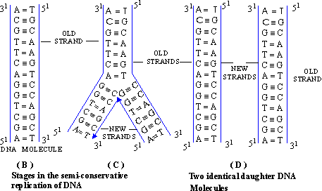
- DNA
  - DNA is the chemical that makes up your genes and chromosomes.
    - Analogy: If your genes and chromosomes are the “instruction manual” for your body, DNA would be the paper it is printed on.
  - The shape of a DNA molecule is a_______________________, which resembles a twisted ladder.
  - The shape of DNA allows it to _________________________ (copy) itself almost perfectly.
  - DNA is made of 4 bases: ____________________.
    - Base pairs: _________ and __________
      - in RNA the pairs are __________ and ____________

- Protein Synthesis: This is how genes control your body:
  - A codon is a sequence of __________bases in DNA.
      - Each codon represents a specific amino acid.
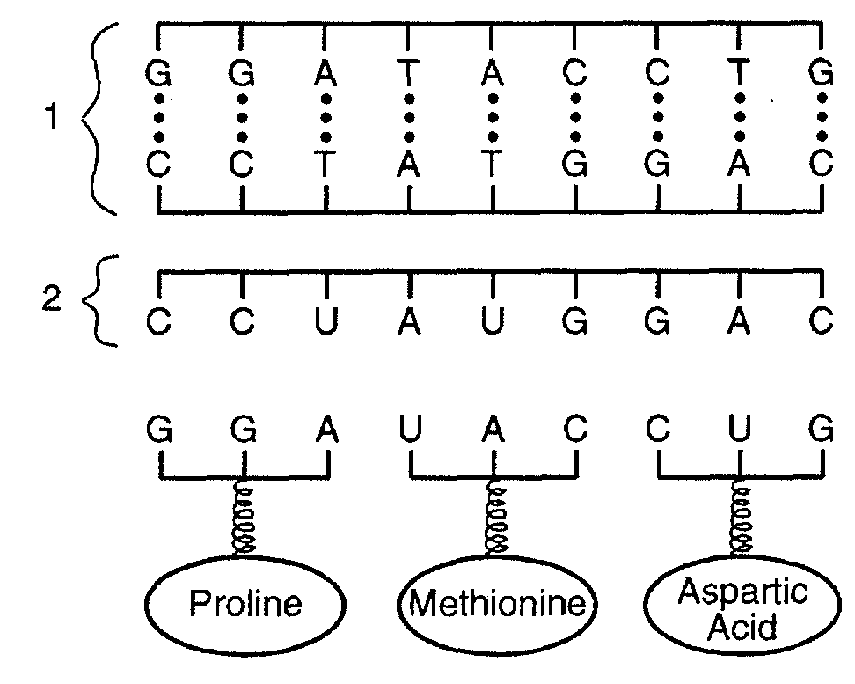
      - ______________________ assemble amino acids in the same order that they are listed in the DNA codons.
      - The amino acids will make a __________________.
      - The order of the amino acids (determined by the DNA sequence) determines the _____________ of the protein.
      - The shape of a protein determines its _____________________.
      - Therefore: The sequence of bases in DNA will determine the ____________________ of all the proteins in the body.
      - The proteins build and run the body.
  - ______ carries the genetic code to ribosomes.

The order of DNA __________ in your genes determines the order of _____________________ in your proteins, which determines the protein’s ______________ and ______________________.
Therefore: How your body functions depends on the order of the bases in your genes!
- Mutations: ___________________________________________________________________
  - Can only be passed on if they occur in reproductive cells (sperm or egg).
  - Common mutagenic agents include ____________________________________________.
    - Mutagenic agent: ________________________________________________________.
  - Gene mutations may cause a change in a gene which can change the __________ of a ___________. This will have an effect on the way the protein works (if it still works at all).
    - Gene mutations are caused when DNA bases are in some way changed.
  - Chromosome mutations are usually caused when a person inherits too many or too few chromosomes.
    - Chromosome mutations affect many genes at once. Most are lethal
    - Down’s Syndrome: Non lethal mutation, caused by inheritance of an extra copy of chromosome 21. (Note – only chromosome 21 can cause Down Syndrome).

- Genetic technology:
  - Selective breeding:__________________________________________________________ __________________________________________________________________________
Ex:

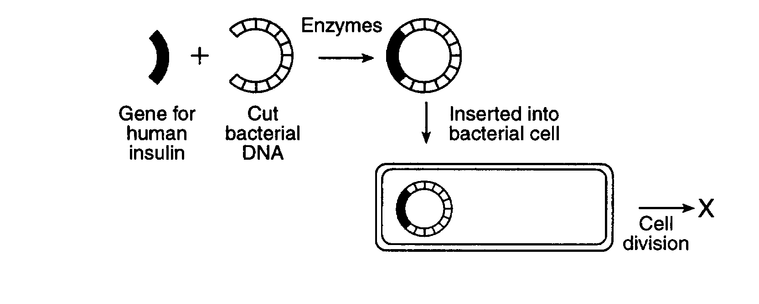
  - Genetic engineering: ________________________________________________________ __________________________________________________________________________.
    - ____________________are used to cut and paste the DNA segments.
    - Organism that receives the new gene will begin to make the _______________, ___________________ or _______________________ coded for by that gene.
    - The new protein/enzyme/hormone will be ___________________________________ as the one produced by the original organism.
    - _________________are often used because they are simple and reproduce quickly.
    - The example of gene splicing you MUST know:
      - Bacteria have been engineered to make ______________________ fo r diabetics.
      - Bacteria have been engineered to make ________________________________.
      - In both cases the engineered hormones are safe to use because they are identical to normal human hormones.

  - New technologies (karyotyping, DNA fingerprinting) are making it easier to diagnose and treat genetic disease, though we cannot yet cure them.
    - Karyotype: A photograph of an organism’s chromosomes.
      - Can determine if a person has a chromosome disorder such as Down Syndrome.
    - DNA finerprinting, or gel electrophoresis, creates banded patterns based on a person’s DNA base sequence.
      - Each fingerprint is unique, so it can be used to identify people.
      - Fingerprints of relatives are similar to each other, so can be used to determine genetic relationships between two people, or even two groups of organisms.
  - Genetic research has posed many ethical problems (ie right and wrong) that science alone cannot answer.
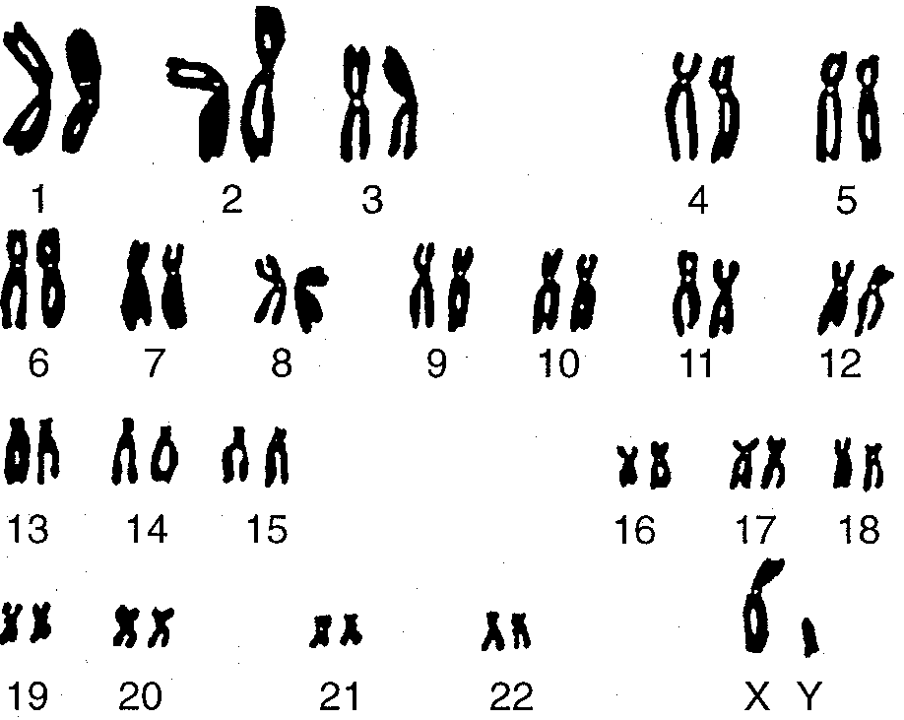
    - Ethics: _________________________________________________________________
A karyotype shows all 23 pairs of human chromosomes. Note the last pair identifies this as a male.

Topic Seven: Evolution
- Evolution: _____________________________________________________________________
- Modern Theory of Evolution:
  - Charles Darwin:
    - Was not the first to think of evolution, but he did figure out how it works (mostly).
    - Darwin didn’t know about genes, so he couldn’t know about mutations.
  - The modern theory (which combines Darwin’s ideas with genetics and other new ideas) contains the following ideas:
    - Earth is old (4.55 billion years) and is constantly changing.
    - As the environment changes, evolution causes species to adapt to their environment.
    - ______________________________________ is the mechanism that causes species to change.
    - Common Descent: Modern species evolved from earlier, different species and share a common ancestor.
    - Species that can not adapt become _____________________.
    - New traits arise in a species from ___________________________ and _____________________________________________.

- Environment and Evolution: Species usually evolve when the environment changes.
  - Changes need to be long term – species do not evolve because of changes in the season.
  - Changes can include:
    - Climate change
    - Change in temp
    - Change in water availability
    - Change in food availability
    - Introduction of new species (new food, new predator)
    - Species may be moved to a new location (accidentally taken to an island for example)
  - Environmental change DOES NOT CAUSE evolution to occur. A temperature or climate change does not itself force a species to change its inherited characteristics.
    - If this were the case, then all species would be able to adapt to the new environment, and extinction would be a very rare event.

- Natural Selection: The basic steps in natural selection are:
  - __________________________________: Members of a species are different from each other due to mutations and sexual reproduction.
    - No variation = no evolution or natural selection, as there is nothing to “select.”
      - Species with no variation are usually the first to die when the environment changes.
  - ___________________________________: Too many offspring are produced.
  - ______________________________: Offspring must struggle to survive and reproduce.
  - ______________________________:
    - Offspring who inherited “fit” traits are, on average, better able to get resources, escape from predators and find mates.
    - Offspring with “unfit” traits will have more difficulty surviving and finding mates.
    - Fitness: A measure of how well a trait helps an organism to survive and reproduce in its environment. Note that there is no absolute rule for fitness – what is fit in one environment may be unfit in another.
    - Note: This “selection” is not a conscious act – no one is “choosing” who survives and who doesn’t. It is the result of the conditions of the organism’s environment.
  - ________________________________:
    - More fit organisms reproduce and pass on their genes than unfit organisms.
    - On average, the next generation will have more traits from the “fit” parents than the unfit ones.
    - NOTE: Traits are still inherited randomly. Individuals offspring of “fit” parents can still inherit “unfit” traits (though it will be unlikely to survive and reproduce). It is only by looking at the ENTIRE population that you will see the “fit” traits become more common.
  - _____________________: Evolution does not happen overnight. It takes many generations of repetitive selection to weed out the unfit traits.

- Speciation: The process of making a new species from an existing one.
  - Geographic Isolation: A population is separated into 2 or more different habitats.
  - New variation and adaptation: Each population adapts to its new environment in different ways. This results in physical and genetic differences between the two populations.
  - Add time: The longer two populations are apart, the greater their differences will become.
  - Reproductive Isolation: Eventually the populations change so much that they are unable to interbreed, even when brought together.
    - Once two populations can no longer breed together, they are considered new species.

- Classification- Organisms are classified based on their evolutionary relationship.
  - Kingdoms are large groups of related organisms (fungi, bacteria, protists, animals, plants).
  - A species is able to successfully reproduce amongst its members.
    - Note that this is not a perfect definition – Lions and tigers can breed together, as can dogs and wolves. Because evolution is a constantly ongoing and gradual process, there are many, many examples in which the lines between species are blurry (see Ring Species)
  - Branching tree diagrams (cladograms) are often used to show evolutionary relationships.

- Evidence: Evidence in support of evolution comes from many fields:
  - Fossil record preserves extinct speices as well as transitional forms between different types of organisms.
  - Radiometric Dating of rocks consistently confirm the age of the Earth and fossils
  - Comparisons of the anatomy (physical structures), embryology (development), chemistry and genes of species confirm expected relationships.
  - Direct observation: Humans have seen evolution occur both in nature and in the lab. Examples include:
    - Bacteria evolving resistance to antibiotics.
    - Insects evolving resistance to pesticides.
    - Modeling natural selection with selective breeding to alter a species’ traits.
    - Observed examples of speciation

- Common Mistakes
  - “Stronger organisms are more fit than weak ones.”
Evolutionary fitness is not physical fitness. Fitness is determined by who is better adapted to survive in a particular environment and who can pass on their genes. Stronger is not always better. There are many examples of species for whom it is better to be slow, weak, or stupid, than fast, strong or smart. It all depends on the environment you are in.
  - “The organism evolved to live in its environment.”
Individual organisms do not evolve. Only populations can evolve.
  - “The organism could not adapt and it went extinct.”
Individual organisms die; they cannot go extinct. Only species can become extinct.
  - “The bacteria became resistant to antibiotics when they were exposed to them”
To evolve, variations must exist in a species BEFORE the environment changes (pre-adaptation). Bacteria who did not already have a resistance to antibiotics would die when exposed to them, a Chihuahua who is left out in the cold will not grow long, warm fur and a squirrel who plays in traffic will not evolve automobile resistance.
  - “Giraffes got long necks because they needed them to eat leaves at the tops of trees.” Species do not evolve traits because they need them - Life would be much better if we could! Short necked giraffes were never given long necks any more than slower antelopes are given speed when confronted by a predator. The reason there are no short necked giraffes (or slow antelope) is that they were out competed by members of their species with more fit traits. Better answers are
      - “Giraffes evolved long necks because the ones with longer necks were better adapted to get food than short neck giraffes.”
      - “Giraffes evolved long necks because more short necked giraffes died, and more long neck giraffes lived and reproduced.”

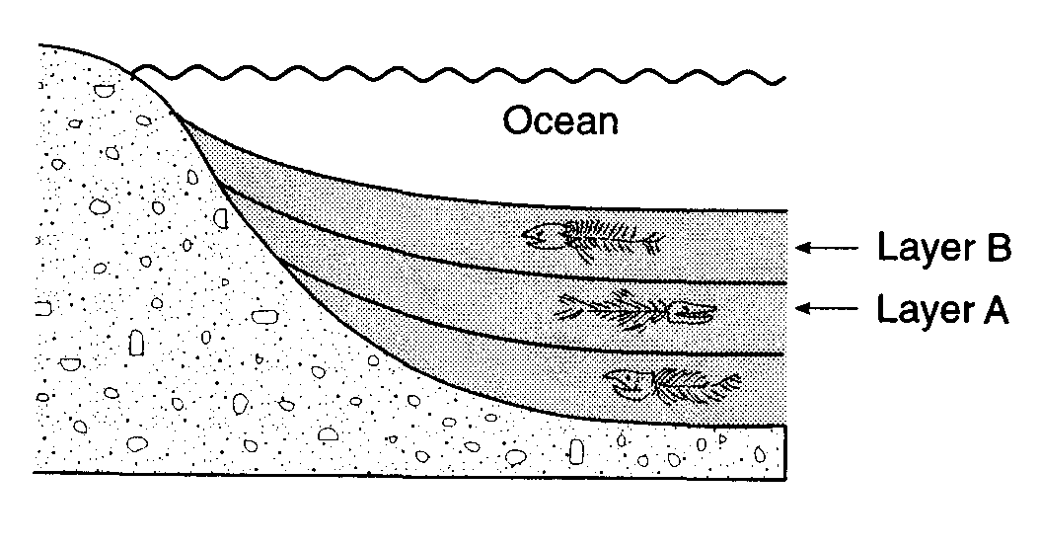
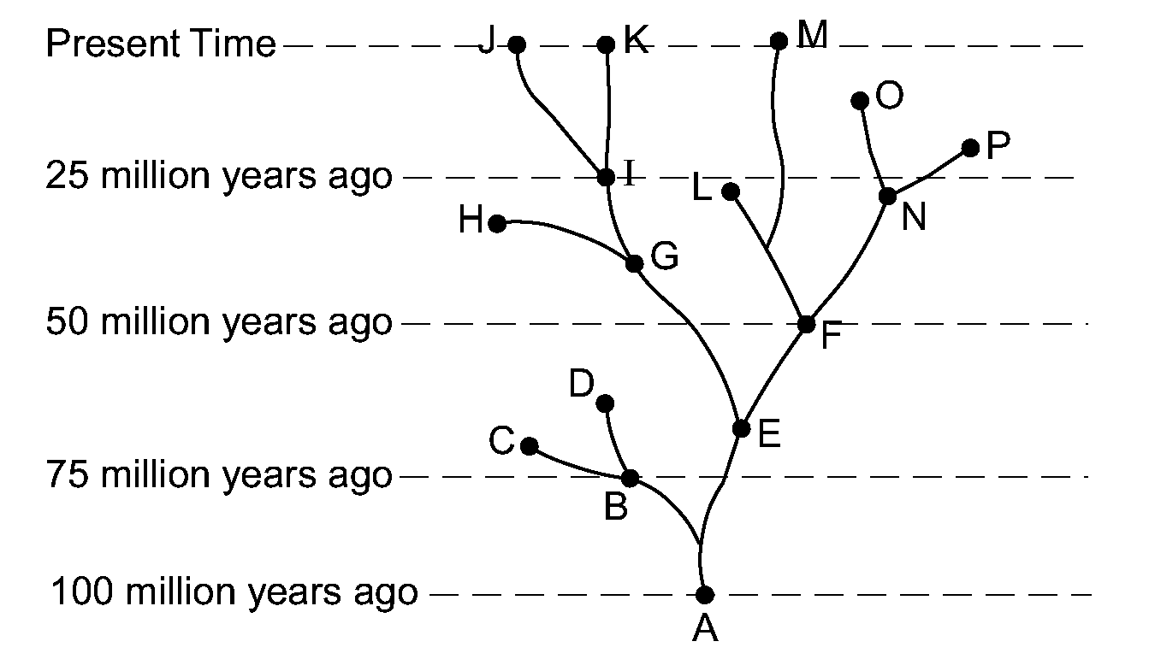
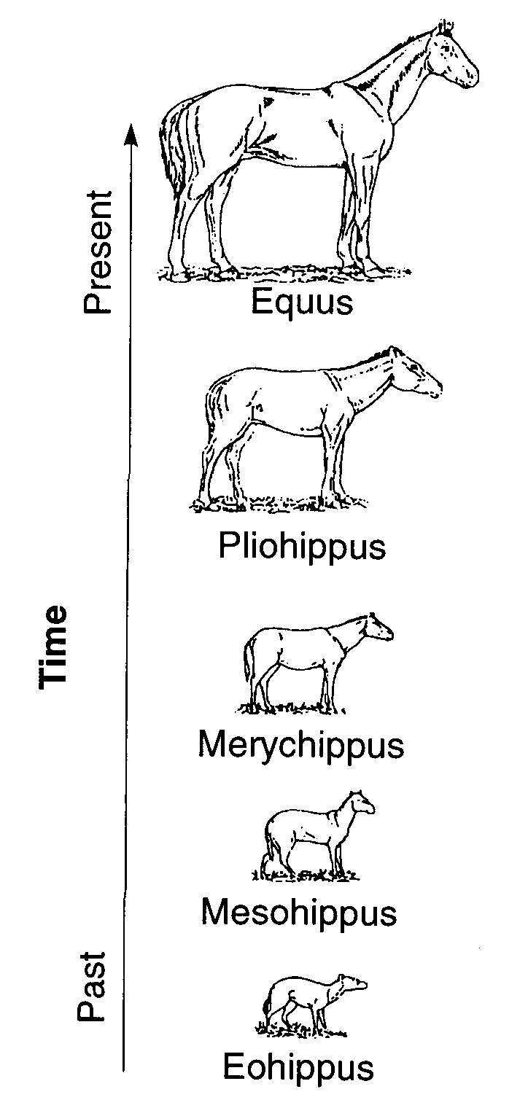
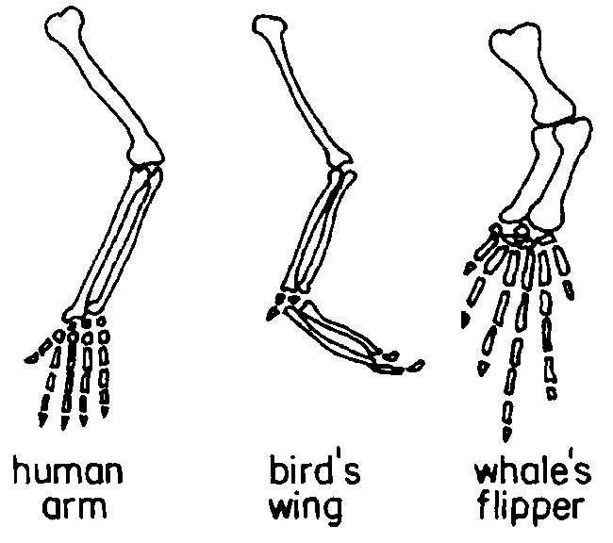
Topic Eight: Ecology
Deeper fossils are typically older than those above them.
Transitional forms for many species can be found in the fossil record. This diagram shows the evolution of the modern horse from a small, many-toed ancestor.
Homologous Structures reveal that the same body parts can be modified to perform different functions.
Evolutionary trees can show the relationship between living and extinct species.
- Ecology: ______________________________________________________________________
  - Habitat: ____________________________________________
  - Niche: ______________________________________________
    - Two species in an ecosystem trying to fill the same niche will create________________________ , which usually results in only one species occupying a niche at any one time. Organisms with similar needs will often divide resources to reduce competition (ex: birds eat insects during the day, bats eat them at night).
  - How organisms interact with each other:
    - Competition: ____________________________________________________________
Ex: A squirrel and a chipmunk compete for food.
    - Feeding: One organism feeds on another.
      - Producer – An autotroph; organisms that makes its own nutrients from simple substances.
      - Consumer – A heterotroph; may be an herbivore, carnivore, omnivore or decomposer.
    - Symbiosis: A close relationship between two organisms in which at least one benefits.
      - Can include 2 organisms working together for mutual benefit (bee and flower) or 1 organism harming another (parasite-host).

- Organization
  - Abiotic Factors: ________________________________________
  - Biotic Factors: _________________________________________
  - Levels of organization:

- Populations: A given area can only supply enough resources for a limited number of organisms.
  - Carrying capacity: __________________________________________________
  - Limiting factors: Anything which limits the size of a population, including:

  - Overpopulation: When a population exceeds the carrying capacity. Usually results in a large number of organisms dying off until a new balance is reached.

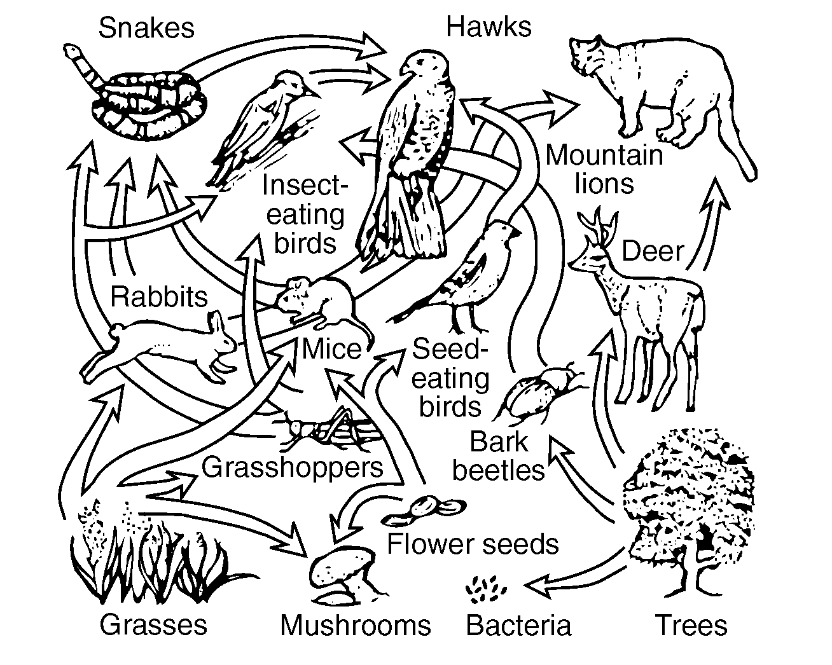
- Energy in an Ecosystem
  - _______________ provides all energy for life on Earth.
  - Sun’s energy is stored in the chemical _______________ of food through the process of ___________________________.
  - Food chain – Shows 1 way that energy can “flow” through an ecosystem.

  - Food web – Shows many energy pathways.
  - Energy pyramid: Shows that energy gets lost with each step in a food chain
    - Energy is lost because every organism uses some of the energy for it’s own life processes. Only about 10% of energy is passed from one step to the next.
    - This is why populations of predators are typically less than the populations of their prey.
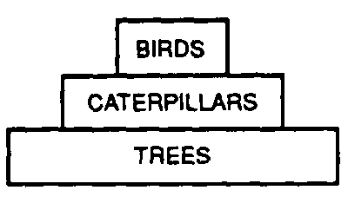

- Biodiversity refers to the variety of life on earth.
  - Diverse ecosystems (those with many types of species) are more stable than ones that are not diverse.
  - As habitats are lost and species become extinct, biodiversity is reduced. This is considered to be bad because:
    - Ecosystems with low diversity are less stable than ecosystems with more diversity,
    - Ecosystems with low diversity take longer to recover from environmental changes
    - Humans use organisms for many things such as food and medicine; by reducing biodiversity we are losing potentially valuable resources.

- Ecological Succession: ___________________________________________________________ ______________________________________________________________________________
  - The organisms in each stage of succession change the environment, and allow new organisms to move in and replace them.
  - Climax Community: __________________________________________________________
    - The climax community is determined by the local climate.
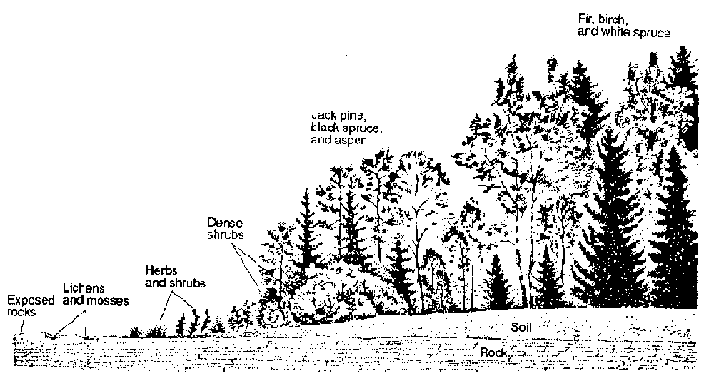
      - Ex: Kansas has very fertile soil, but not enough rain to support trees, so succession stops with grasses and shrubs.
  - Any temporary disruption of a community will begin the process of succession all over again.
      - Ex: If a forest fire kills all the trees in an area, succession will eventually return the area back into a forest, but it much first pass through all the necessary stages.

- Human Impact: Human actions can have both a negative or positive impact on the environment.
  - The primary reason humans have a negative impact on the environment is because the human population is growing, which places a greater demand on resources such as food, water and space.
  - There are no easy solutions to any ecological problem. Every solution can have negative consequences. Choosing the “right” actions requires weighing the benefits with the risks.
  - Human actions that generally have a negative impact on the environment include:
    - Development/industrialization
    - Pollution
    - Farming
    - Overhunting,/overgrazing
    - Clear cutting/deforestation
    - Introduction of foreign species
  - Actions being taken by humans to reduce or repair damage to the environment include:
    - Recycling wastes
    - Conserving available resources
    - Using cleaner resources (ex: solar over fossil fuels)
    - Protection of habitats and endangered species
    - Use of biological controls instead of pesticides and herbicides
    - Farming native plants (ex: cocoa in the rainforest)
    - Planting trees to replace those cut down.
    - Rotating crops or planting cover crops to reduce soil loss.
    - Passing laws to control pollution, land management, hunting, fishing, etc.

- Specific Environmental Problems:
  - Acid rain
    - Cause:
    - Negative effect:
    - What can be done:

  - Depletion of ozone layer
    - Cause:
    - Negative effect:
    - What can be done:

  - Industrialization
    - Cause:
    - Negative effect:
    - What can be done:

  - Loss of habitat (ex: deforestation)
    - Cause:
    - Negative effect:
    - What can be done:
  - Loss of diversity
    - Cause:
    - Negative effect:
    - What can be done:

  - Global warming
    - Cause:
    - Negative effect:
    - What can be done:

  - Introduced species
    - Cause:
    - Negative effect:
    - What can be done:

Topic Nine: Experiments and Labs
Example of a Controlled Experiment:
Hypothesis:
If people chew gum it will improve their memory.
Independent variable:
Chewing gum – some people will chew gum, some will not.

Dependent variable
Memory – all groups should have their memory checked both before and after the experiment to see if it was improved.

Experimental Group
Group that chews gum.

Control Group
Doesn’t chew gum (remember – the control group never receives the new treatment)

Constants
Should be the same for both groups:
People in each group should be of similar health with similar memory, with similar mixes of sexes, ages, and ethnicities. Each group should also be tested in the same way.

Data Collected
You should test people’s memories both before and after the experiment.

- Terms:
  - Observation: What is seen or measured.
  - Inference: A conclusion based on observation or evidence.
  - Hypothesis: A prediction based on available evidence. A good hypothesis states both cause and effect.
    - A correct hypothesis can be tested and falsified (proven incorrect) using an experiment.
    - The easiest way to write a correct hypothesis is as an “if-then” statement. (ex: If I give patients this pill, then they will not get sick.)
  - Theory: An explanation of natural events that is supported by strong evidence.
    - Theories tie together many scientific facts, hypotheses and laws.
    - Common Mistake: “Theories are things that are opinions, or are not proven.”
This is an incorrect use of the word “theory” in a scientific context. A scientific theory is not a simple guess or conjecture, and is strongly supported by evidence.

- Controlled Experiments: Compares the results of an experiment between one or more experimental groups with a “normal” group.
  - Experimental group: Group being tested or receiving treatment.
  - Control group: “Normal” group. Should be identical to experimental group in every way except one: it does not receive the new treatment.

  - Placebo: A sugar pill or other “fake” treatment given to the control group. Usually only needed when using human subjects.

  - Independent Variable: Variable that is being tested (ex: new drug, new fertilizer).
    - The “If” part of an “If-then” hypothesis.
    - The independent variable is always plotted on the X axis.

  - Dependent Variable: Variable that is measured at the end of an experiment; the results.
    - The “then” part of an “If-then” hypothesis.
    - The dependent variable is always plotted on the Y axis.

- Graphs and Data Tables
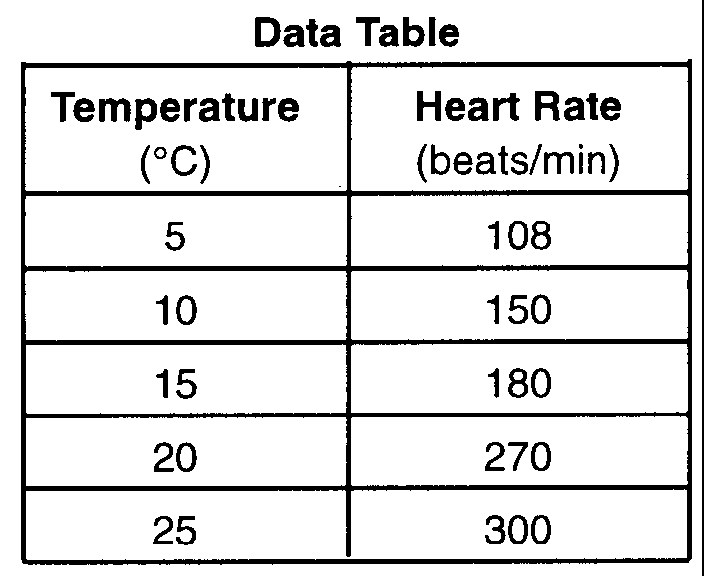
  - Data tables are used to organize data which will be plotted in a graph.
    - First column in the table is for the independent variable.
    - Second column is another for the dependent variable.
    - Each column should be titled, and include units of measurement.
    - Data in the table must be arranged in ascending or descending
order.

  - Both the x and y axis of the graph must be labeled or titled. These labels are typically the same ones used in the data table. Once again units of measurement must be written with the title.
    - The independent variable is always plotted on the x-axis.
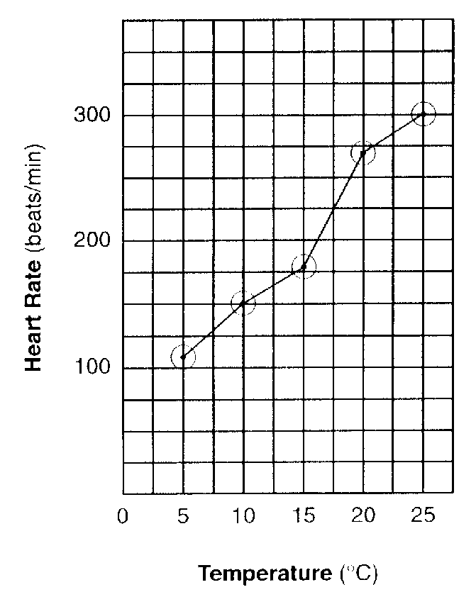
    - The dependent variable is always plotted on the y-axis.

  - The x and y axis must be numbered.
    - These numbers must increase by a uniform increment (that is you must count by 1’s, 2’s, 5’s, 10’s, etc).
    - Your numerical scales should take up most of the axes. Squeezing it all into the bottom corner makes the graph impossible to read and no credit will be given.
    - The numbers must line up with the grid lines of the graph, not with spaces between them.
    - You do not need to start numbering your axis with 0.

  - To date, all graphs drawn on the LE Regents have been line graphs. Any student who draws a bar graph instead of a line graph will be denied credit for this part of the test.

  - All points plotted on your graph must be surrounded by a circle (or sometimes a square or triangle, depending on the directions).
- Characteristics of a good experiment:
  - Can be repeated the same way and get the same results.

  - Have large sample size/many test subjects.

  - Are performed over longer periods of time.

  - Test only one independent variable. All other characteristics of the tested groups should be the same.

  - Are peer reviewed – examined by other scientists to determine its accuracy.

  - Must test the hypothesis and show whether it is wrong or right.

  - Is objective – the experiment and conclusion are fair and unbiased. Fact and opinion are not mixed.

  - The experiment follows established ethical and legal standards.

Topic Ten: The State Labs (Part D)
- Making Connections (aka The Clothespin Lab)
  - Part A
    - What you did: measured how exercise affected pulse rate.
    - What you learned: exercise increases pulse rate
  - Part A2
    - What you did: Squeezed a clothespin for 1 minute, then squeezed it again for another minute
    - What you learned:
      - If you squeezed more the second round, it may have been because your finger muscles were “warmed up” from increased circulation.
      - If you squeezed less the second round, it may have been because your finger muscles were fatigued.
  - Part B
    - What you did: Designed an experiment to test how exercise affects squeezing a clothespin.
    - What you learned: How to design an experiment (see pages 3-5).

- Relationships and Biodiversity (Botana curus lab)
  - What you did: Compared 4 species of plants, based on structural (physical) and molecular (chemical and genetic) traits.
  - What you learned:
    - Species that are related share similar traits.
    - Different techniques (such as gel electrophoresis and paper chromatography) can be used to determine relationships between organisms.
    - Endangered species should be protected because they may offer benefits to humans.
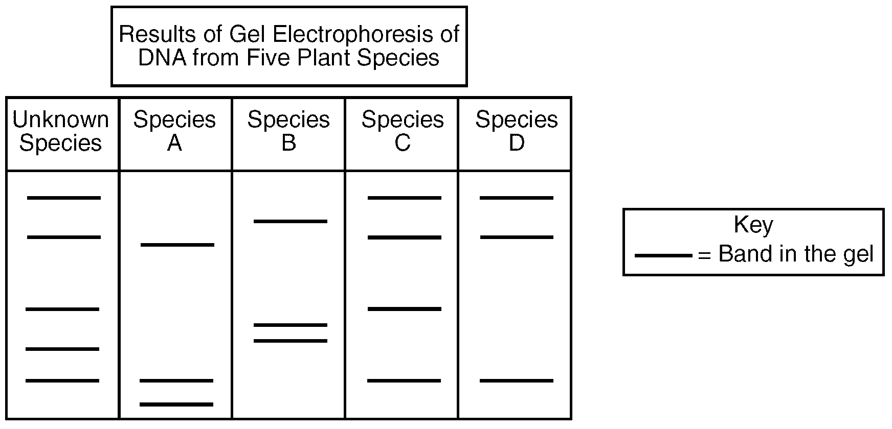
Gel Electrophoresis – A technique used to show how species are related to one another.
Restriction enzymes cut DNA into fragments, which are placed into a well in a gel plate.
An electric current carries the DNA fragments through the gel, separating them according to size (smaller pieces of DNA are carried farther from the well than larger pieces). This creates a pattern of bands which is unique for every organism.
Related organisms will show similar banding patterns because their DNA have similar base sequences.
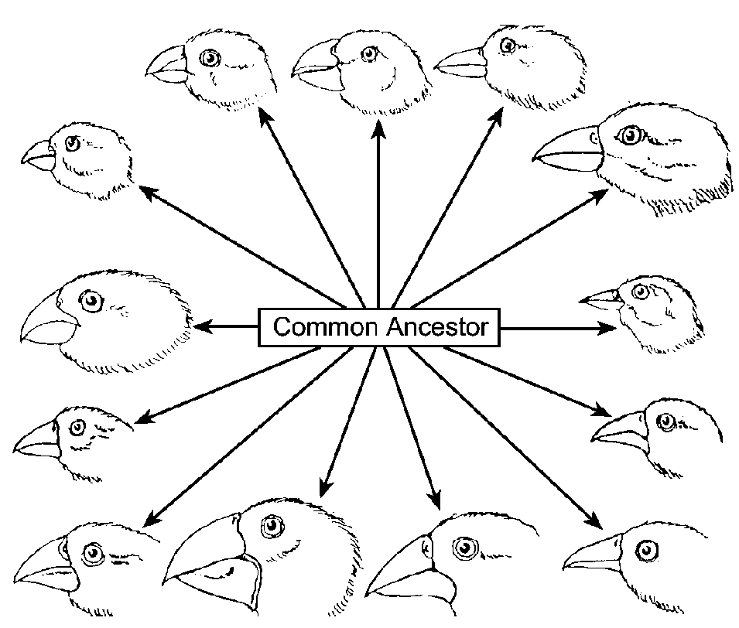
- Beaks of Finches
  - What you did: Played different finch species competing for food.
  - What you learned: Different environmental conditions (food) favored different species of finch, allowing some to survive and reproduce, but not others.

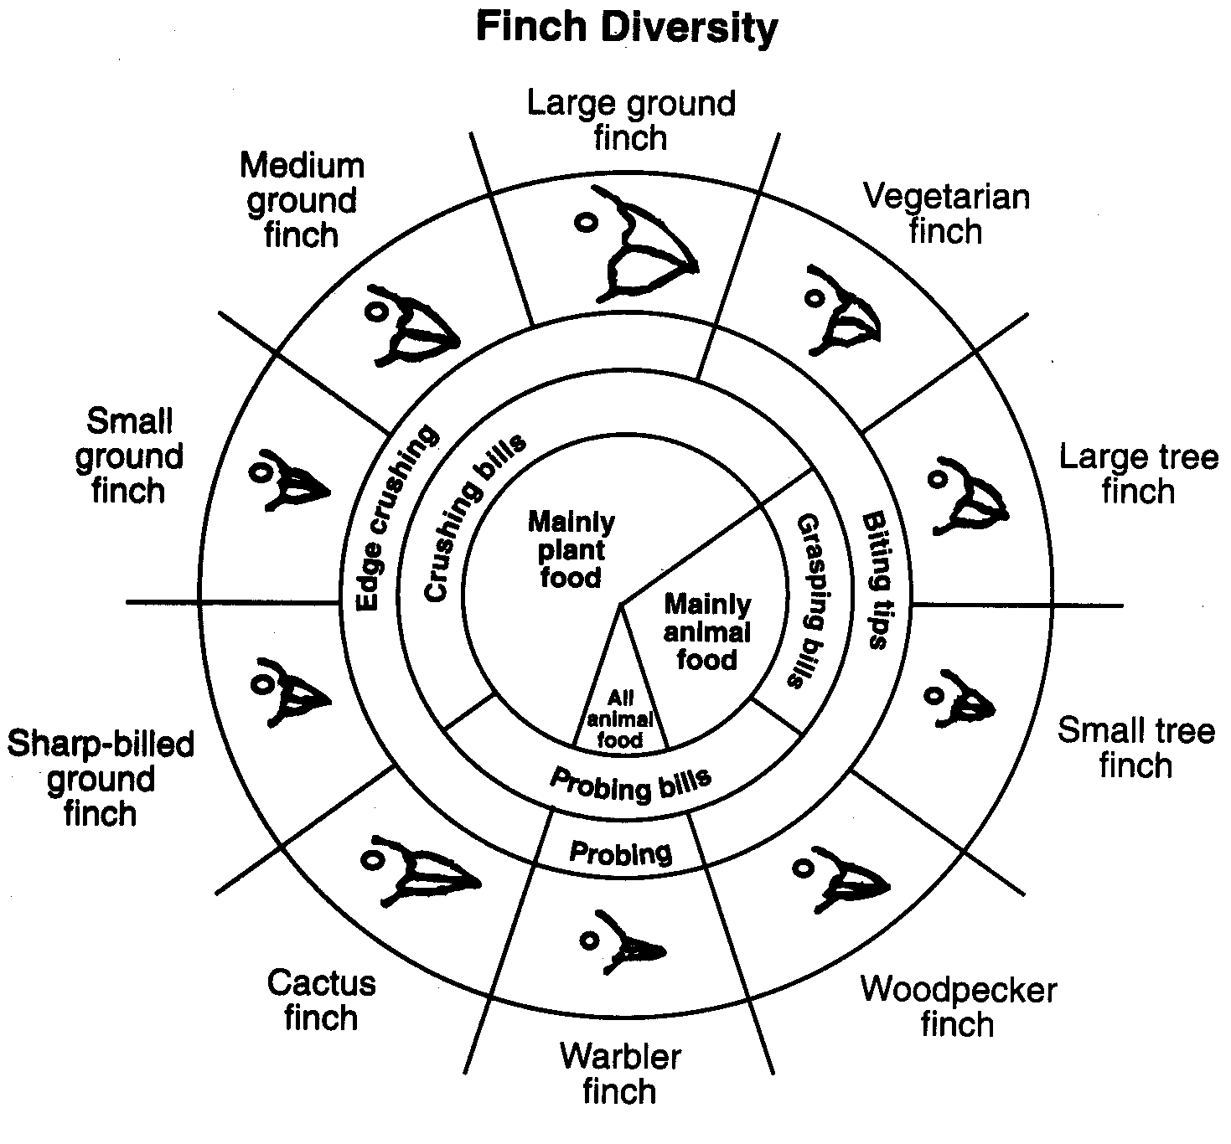
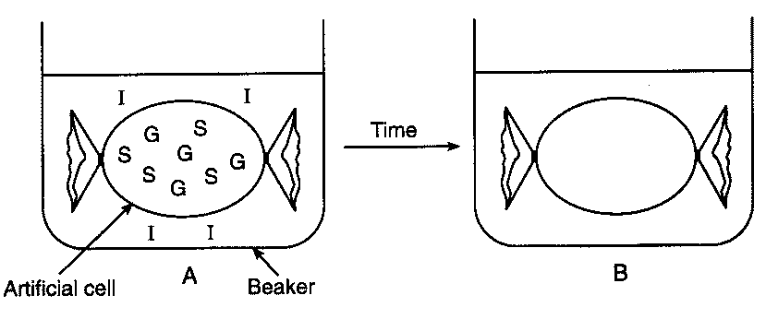
- Diffusion Through A Membrane
  - Part A
    - What you did:
      - Made a model cell using dialysis tubing.
      - Put glucose and starch inside your “cell.”
      - Put starch indicator (iodine) outside cell
    - What you saw:
      - Inside of cell turned black because iodine diffused into the cell
      - Because outside of the cell was not black, you know the starch did not diffuse through the membrane.
      - Used blue glucose indicator (Benedict’s solution) to see that glucose did diffuse through the membrane.
    - What you learned
      - Small molecules (glucose, iodine) can diffuse through a membrane on their own.
      - Large molecule (starch) cannot diffuse through a membrane on their own.
      - You can use indicators to identify the presence of specific substances.

  - Part B
    - What you did:
      - Looked at red onion cells under the microscope.
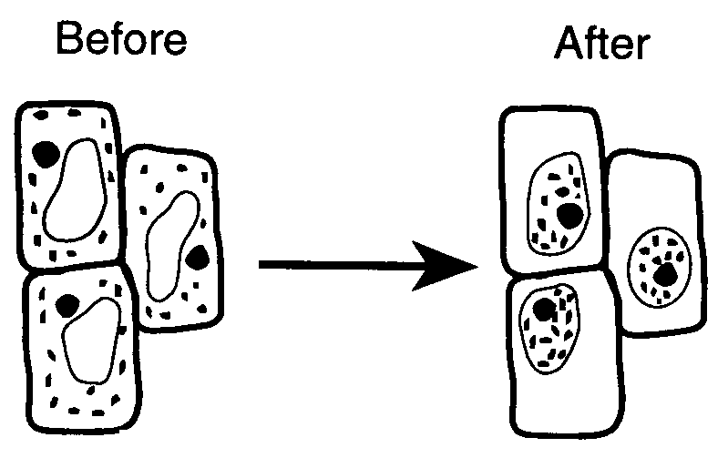
      - Added salt water to the onion cells.
      - Added distilled (pure) water to the onion cells.
    - What you saw:
      - Salt water caused the onion cells to shrivel.
      - Distilled water cause the cells to swell back to normal.
    - What you learned:
      - Salt water causes water to diffuse out of a cell.
      - In pure water, water will diffuse into a cell.

