Name: __________________________________ Date Completed: _____________________________

Class: ____________ Lab Minutes: _______________ Teacher: _______________________________
Purpose: This lab will allow you to practice your graphing skills and review the scientific method and independent and dependent variables.
Materials: pencil/ pen, ruler, colored pencils
Introduction: Graphing is used by scientists to display the data that is collected during a controlled experiment.A line graph must be constructed to accurately depict the data collected. An incorrect graph often
leads to accepting an incorrect hypothesis or rejecting a correct hypothesis.
A graph contains 5 major parts: the title, the independent variable, the dependent variable,
the scales for each variable, and a legend.
1.) The title: this is a statement above the graph that shows what the graph is about.
2.) The Independent Variable: this is the variable (part of the experiment that changes) that
can be controlled or manipulated by the experimenter. This variable should be placed on the
horizontal or x-axis.
3.) The Dependent Variable: this is the variable directly affected by the independent variable.
It is the result of what happens because of the independent variable. This variable is placed
on the y or vertical axis.
4.) The Scales for each Variable: In constructing a graph, a scale must be created that will include
all the data points. Each line should have a consistent amount or increment on a particular
axis. While the scale should allow as much of the graph to be taken up as possible, it is not
a good idea to set up a scale that is hard to manage. For example, multiples of 5, 10, etc.
are good, while multiples such as 1.22 are not! Your scale must be plotted on the amount
of graph space available, and must include all the data points.
5.) The Legend (or Key): this gives an explanation or list of symbols that describe or define the data.
Activity: Data from various experiments is given. Follow the instructions for the graphing and answer the questions on the space given.
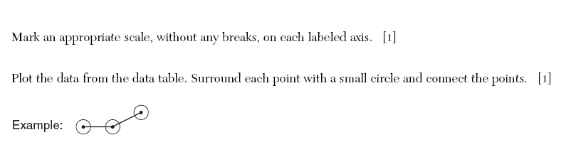

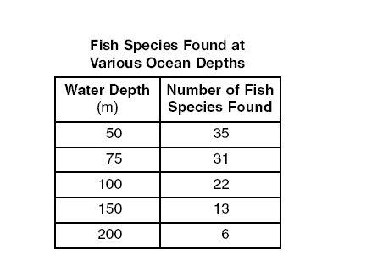

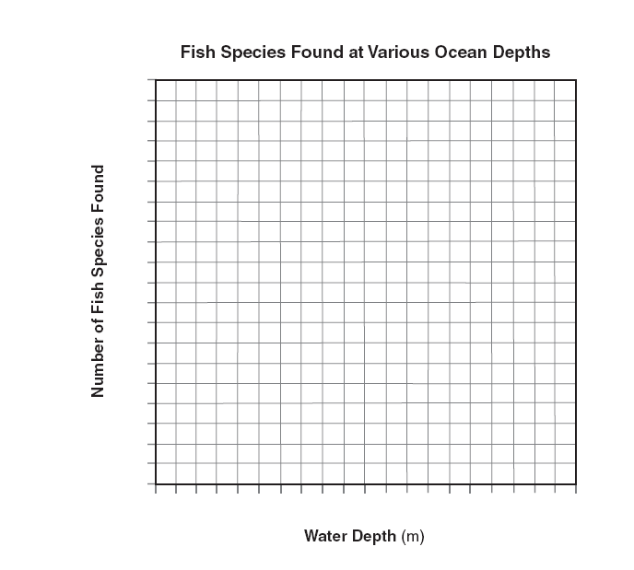
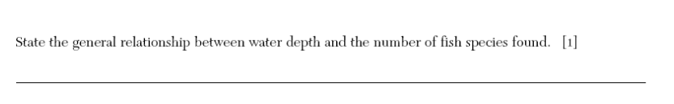
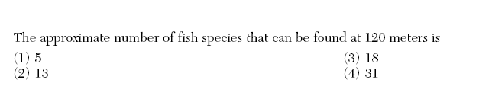
State the independent variable: ______________________________________________
State the dependent variable: ________________________________________________

2.
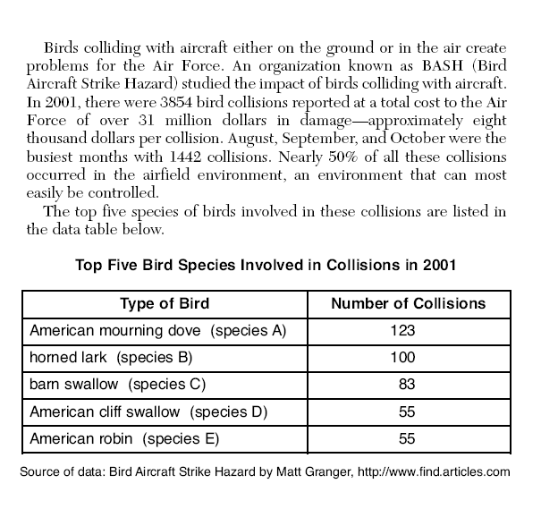
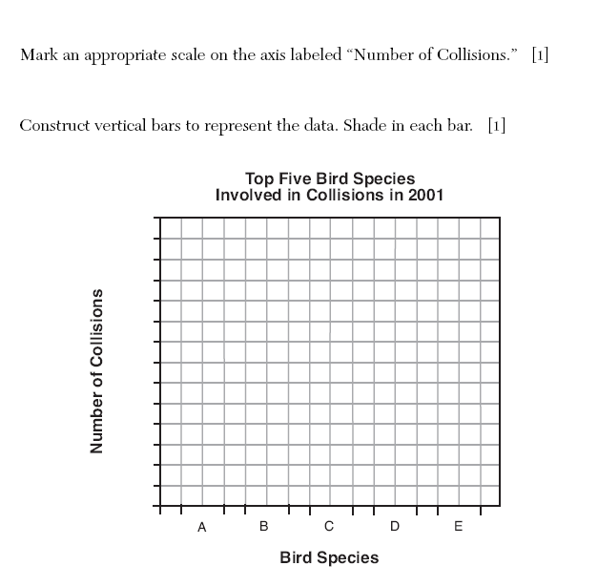
State the independent variable: __________________________________________
State the dependent variable: _____________________________________________
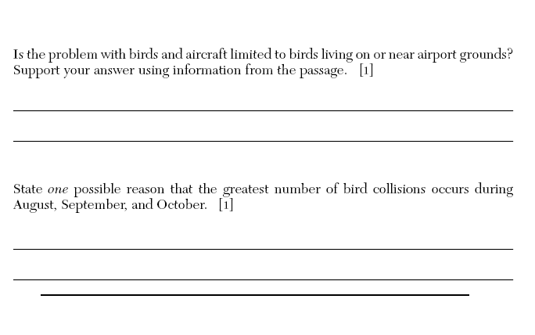
3.
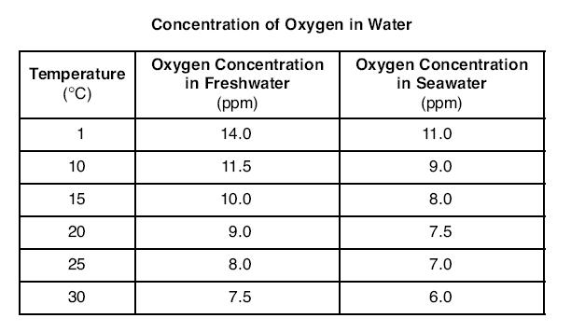

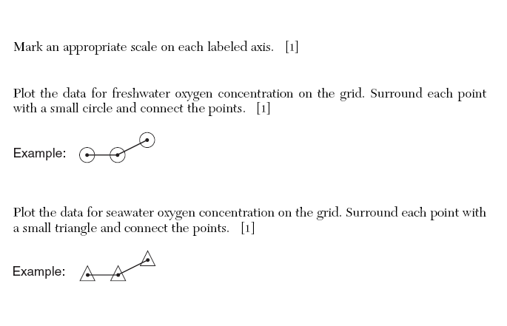
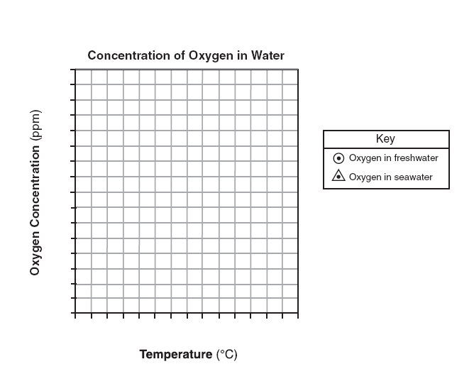
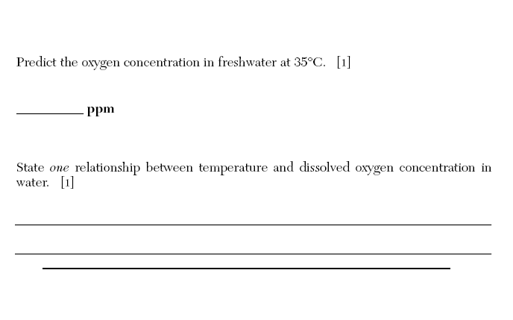
State the independent variable: __________________________________
State the dependent variable: ____________________________________

