Name: ______________________ Class: ____________________________
Frog Dissection Instructions

- Place the frog on a dissection tray.

- Measure the length of the frog from the head to the tip of the toes.
Frog length: _______ cm
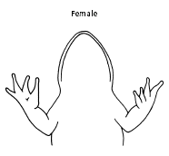
- To determine the frog’s sex, look at the hand digits, or fingers, on its forelegs. A male frog usually has thick pads on its "thumbs," which is one external difference between the sexes, as shown in the diagram below. Male frogs are also usually smaller than female frogs. Observe several frogs to see the difference between males and females.
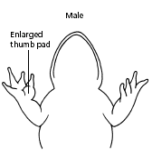
Frog Gender: __________________________

4. Use the diagram below to locate and identify the external features of the head. Find the mouth, external nares, tympani, eyes, and nictitating membranes.
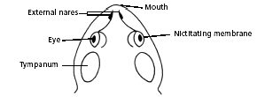

5. Turn the frog on its back and pin down the legs.
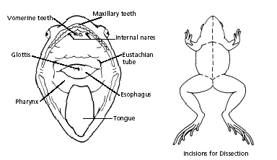
6. Cut the hinges of the mouth and open it wide. Use the diagram below to locate and identify the structures inside the mouth. Use a probe to help find each part: the vomerine teeth, the maxillary teeth, the internal nares, the tongue and the opening to the esophagus.

What does the esophagus connect to? _________________________

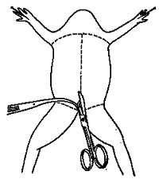
- Look for the opening to the frog’s cloaca, located between the hind legs. Use forceps to lift the skin and use scissors to cut along the center of the body from the cloaca to the lip. Turn back the skin, cut toward the side at each leg, and pin the skin flat. The diagram shows how to make these cuts

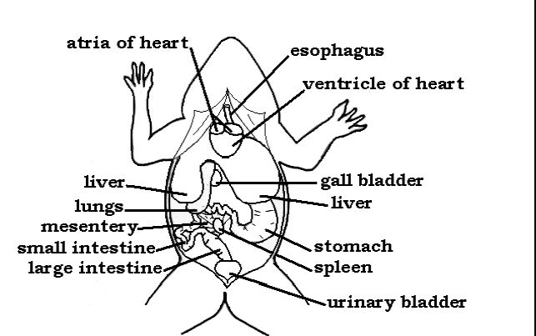
- Lift and cut through the muscles and breastbone to open up the body cavity. If your frog is a female, the abdominal cavity may be filled with dark-colored eggs. If so, remove the eggs so you can see the organs underlying them.
.

- Use the diagram to locate and identify the major organs.

- Use a probe and scissors to lift and remove the intestines and liver.

- Cut the stomach out of the frog and open it up. You may find what remains of the frog's last meal inside. What did you find in the stomach? ______________________

- Remove the small intestine from the body cavity. Stretch the small intestine out and measure it. Intestine length = ________ cm

- Use the diagram to identify the parts of the urinary and reproductive systems.

Optional :
- Dissect a thigh and trace one nerve into a leg muscle. Note the size and texture of the leg muscles. Why do frogs need large leg muscles? __________________________
- Brain and eyeball dissection

